

**FACULTY OF ENGINEERING AND TECHNOLOGY BACHELOR OF TECHNOLOGY**

**Database Management Systems Laboratory**

**(303105203)**

**III – SEM**

**Computer Science & Engineering Department**



**CERTIFICATE**

This is to certify that

Mr GAMIT SNEHIL with Enrolment no. 2203031310008 has successfully completed his laboratory experiments in the Database Management Systems Laboratory (303105203) from the department of COMPUTER SCIENCE & ENGINEERING during the academic year 2023 – 2024.



Date of Submission:......................... Staff In charge:...........................

Head Of Department:...........................................

**TABLE OF CONTENT**

| Sr. No | Experiment Title | Page No | | Date of Start | Date of Completion | Sign | Marks  (out of 10) |
| --- | --- | --- | --- | --- | --- | --- | --- |
| From | To |
| 1. | Advantages of DBMS over FPS |  |  |  |  |  |  |
| 2. | Create Given Tables |  |  |  |  |  |  |
| 3. | Simple Queries |  |  |  |  |  |  |
| 4. | Simple Queries |  |  |  |  |  |  |
| 5. | “Like” Queries |  |  |  |  |  |  |
| 6. | “Aggregate Functions & DML” Queries |  |  |  |  |  |  |
| 7. | “Join” Queries |  |  |  |  |  |  |
| 8. | “Join” Queries |  |  |  |  |  |  |
| 9. | “Miscellaneous” Queries |  |  |  |  |  |  |
| 10. | “PL/SQL Block |  |  |  |  |  |  |

**Practical - No.1**

**Aim: Advantages of DBMS over FPS**

**1. What is DBMS? Explain advantages of DBMS over FPS.**

DBMS stands for Database Management System. It is a software system that enables users to define, create, manipulate, and manage databases. A database is a structured collection of data that is organized and stored in a computer system.

Advantages of DBMS over File Processing Systems (FPS):

1. Data Independence: DBMS provides a layer of abstraction between the physical storage of data and the logical representation, allowing changes in the database structure to be made without affecting the applications that use the data. This provides a higher level of flexibility and adaptability compared to FPS, where data is tightly coupled with the application programs.
2. Data Integrity and Security: DBMS offers mechanisms to enforce data integrity constraints and implement security measures. It provides features such as data validation, referential integrity, and access controls to ensure the accuracy, consistency, and security of the data. In FPS, data integrity and security need to be implemented in each application separately, leading to potential inconsistencies and vulnerabilities.
3. Data Sharing and Consistency: DBMS allows multiple users to access and modify the data concurrently while maintaining data consistency. It manages concurrent access through locking mechanisms and transaction management, ensuring that the data remains consistent and preventing conflicts that can arise in FPS when multiple applications try to access and modify the same data simultaneously.
4. Reduced Data Redundancy and Inconsistency: DBMS promotes data normalization, which minimizes data redundancy and ensures consistency. In FPS, data redundancy is common as each application typically maintains its own data files, leading to inconsistencies when the same data is duplicated and updated independently in different files.
5. Querying and Reporting: DBMS provides a query language (e.g., SQL) that allows users to retrieve and manipulate data using powerful and flexible query capabilities. It simplifies the process of retrieving data, generating reports, and performing complex operations on the database. In FPS, data retrieval and manipulation often require custom programming and file handling, which can be time-consuming and error-prone.
6. Scalability and Performance Optimization: DBMS offers features for optimizing performance, such as indexing, query optimization, and caching mechanisms. It can handle large volumes of data efficiently and scale to accommodate growing data needs. FPS may struggle with performance and scalability as the data and application complexity increase.

Overall, DBMS provides a centralized, structured, and efficient approach to managing data compared to the decentralized and application-specific nature of FPS. It offers advantages such as data independence, data integrity, data sharing, reduced redundancy, querying capabilities, and scalability, making it a preferred choice for managing large and complex databases.

**2. List 15 applications of Database. Explain any 2 how Database can be helpful in managing that application?**

Here are 15 applications of databases:

1. Banking and Financial Systems
2. E-commerce
3. Healthcare Systems
4. Human Resources Management
5. Customer Relationship Management (CRM)
6. Inventory Management
7. Airlines Reservation Systems
8. Education Management Systems
9. Supply Chain Management
10. Social Media Platforms
11. Online Ticketing Systems
12. Geographic Information Systems (GIS)
13. Library Management Systems
14. Hotel and Hospitality Management Systems
15. Government Information Systems

* Education Management System:

An Education Management System (EMS) is a software application designed to efficiently manage various aspects of educational institutions, including schools, colleges, and universities. It encompasses functionalities such as student information management, course administration, academic records maintenance, and communication among stakeholders. At the core of an EMS lies the crucial role played by databases in ensuring effective management.

Databases within an EMS serve as centralized repositories for storing and retrieving educational data. They provide a structured and organized system for managing vast amounts of information related to students, courses, faculty, and administrative processes. By utilizing databases, an EMS can store student information, including personal details, enrolment records, attendance, and examination results, allowing for easy access and retrieval whenever needed. Additionally, databases enable seamless integration of different modules within the system, such as admissions, fee management, and library management. This integration reduces duplication of efforts, ensures data consistency, and enables the generation of comprehensive reports and analytics. Overall, databases play a crucial role in the effective functioning of an EMS by providing secure data storage, facilitating data integration, and empowering educational institutions with valuable insights for informed decision-making.

* Banking and Financial Systems:

Databases are the foundation of banking and financial systems, playing a crucial role in managing customer data, financial transactions, and regulatory compliance. They provide secure storage, efficient retrieval, and seamless processing of financial information.

In banking, databases store and manage customer data, ensuring confidentiality and enabling quick access for inquiries and transactions. They also facilitate real-time recording and tracking of financial transactions, supporting operations like reconciliations and risk management. Additionally, databases help financial institutions meet regulatory requirements by organizing and providing necessary data for compliance and reporting purposes.

Overall, databases are essential for the smooth functioning of banking and financial systems, ensuring secure data management, accurate transaction processing, and adherence to regulatory obligations.

**3. Create the Database for the following:**

1. **Student Details using Excel.**
2. **Employees Details using MS Access.**
3. **Facebook using Excel.**
4. Student Details using Excel.

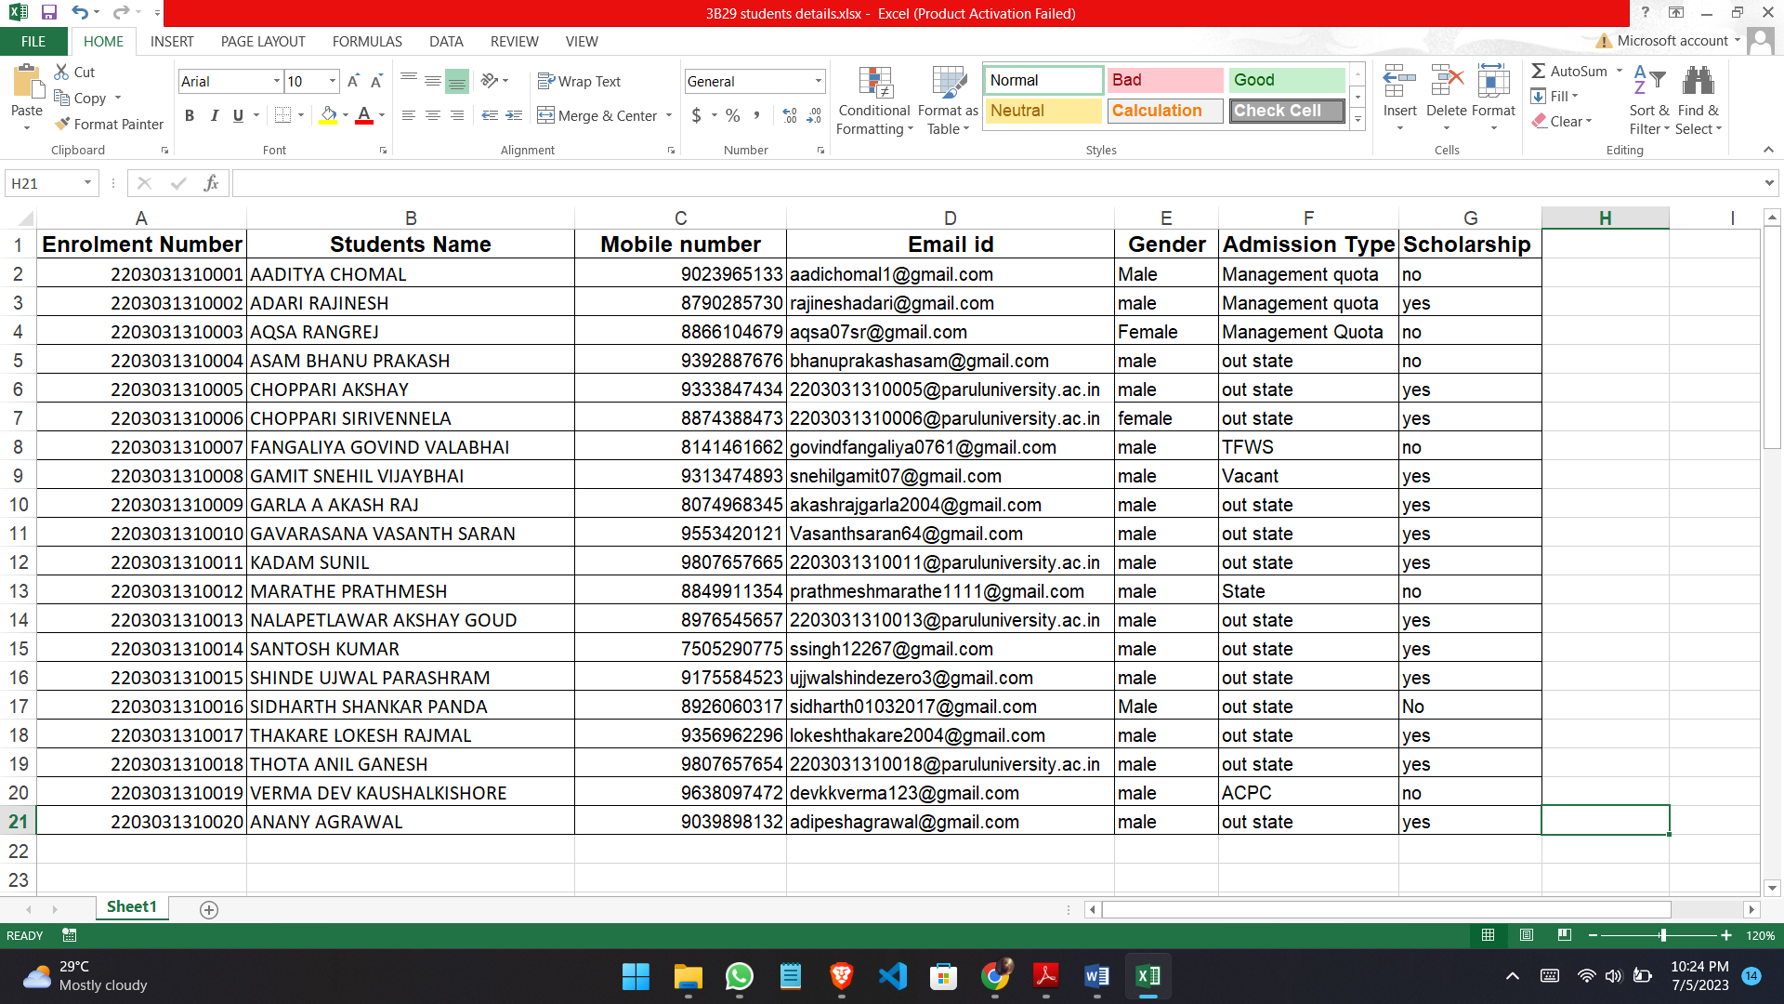

1. Employees Details using MS Access.

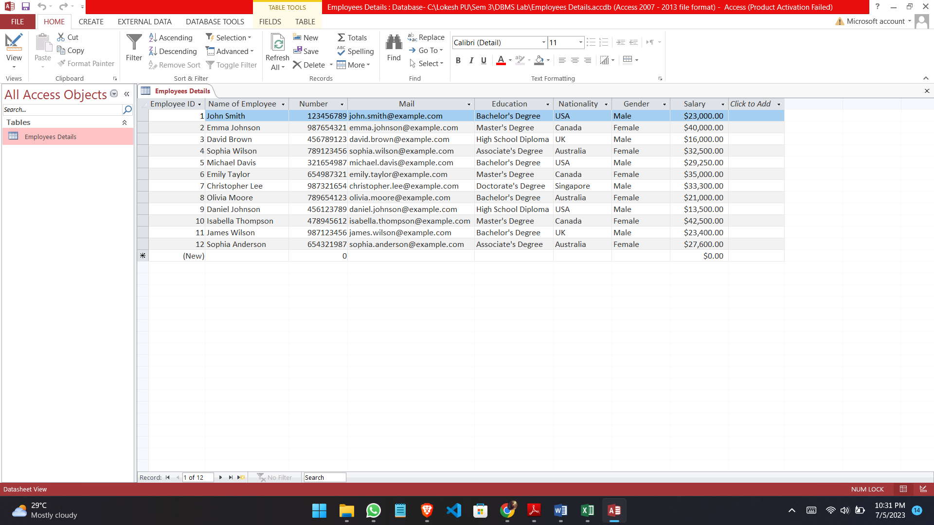

1. Facebook using Excel.

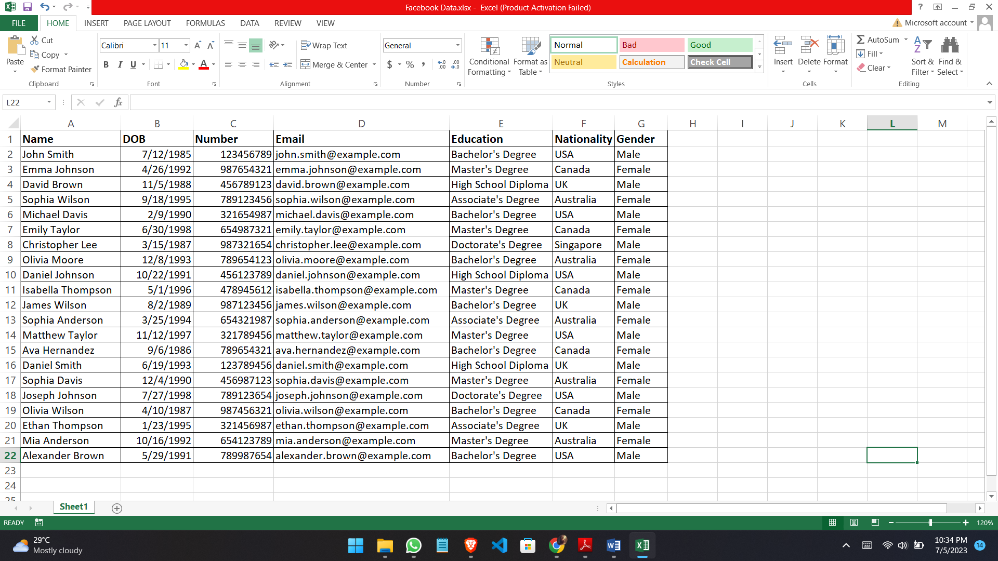

**Practical - No.2**

**Aim: Create Given Tables**

1. **Create table Employee**

**Query:**

create table Employee(Emp_name Varchar(30),Street Varchar(15),City Varchar(30));

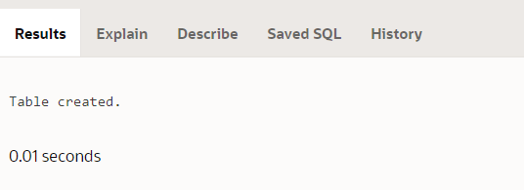

insert into Employee values ('Adam', 'Spring', 'Pittsfield');

insert into Employee values ('Brooks', 'Senator', 'Brooklyn');

insert into Employee values ('Curry', 'North', 'Rye');

insert into Employee values ('Demalo', 'SunShine', 'San Deago');

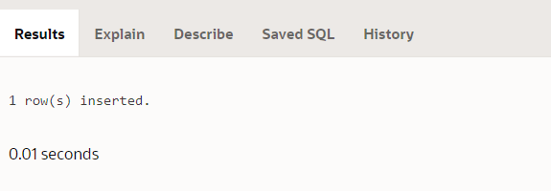

1. **Create table Work**

**Query:**

create table Work(Emp_name Varchar(30),Cmp_name Varchar(15),Salary int);

Table created.

insert into Work values ('Adam', 'FBC', 20000);

insert into Work values ('Brooks', 'MBC', 30000);

insert into Work values ('Curry', 'SBC', 10000);

1 row(s) inserted.

1. **Create table Company**

**Query:**

create table Company(Cmp_name Varchar(30),City Varchar(30));

Table created.

insert into Company values ('FBC', 'Pittsfield');

insert into Company values ('MBC', 'Brooklyn');

insert into Company values ('SBC', 'Rye');

1 row(s) inserted.

1. **Create table Manager**

**Query:**

create table Manager(Emp_name Varchar(30),Man_name Varchar(30));

Table created.

insert into Manager values ('Adam', 'Smith');

insert into Manager values ('Brooks', 'Jones');

insert into Manager values ('Curry', 'Hayes');

1 row(s) inserted.

1. **Create table Sailors**

**Query:**

create table Sailors(Sid int,Sname Varchar(30),Rating int,Age number(3,1));

Table created.

insert into Sailors values (22, 'Dustin', 7, 45.0);

insert into Sailors values (29, 'Brutus', 1, 33.0);

insert into Sailors values (31, 'Lubber', 8, 55.0);

insert into Sailors values (32, 'Andy', 8, 25.5);

insert into Sailors values (58, 'Rusty', 10, 35.0);

insert into Sailors values (64, 'Horatio', 7, 35.0);

insert into Sailors values (71, 'Zobra', 10, 16.0);

insert into Sailors values (74, 'Horatio', 9, 35.0);

insert into Sailors values (85, 'Art', 3, 25.5);

insert into Sailors values (95, 'Bob', 3, 63.5);

1 row(s) inserted.

1. **Create table Reserves**

**Query:**

create table Reserves(Sid int,Bid int,Day date);

Table created.

insert into Reserves values (22, 101, '10-10-98');

insert into Reserves values (22, 102, '10-10-98');

insert into Reserves values (22, 103, '08-10-98');

insert into Reserves values (22, 104, '07-10-98');

insert into Reserves values (31, 102, '10-11-98');

insert into Reserves values (31, 103, '06-11-98');

insert into Reserves values (31, 104, '12-11-98');

insert into Reserves values (64, 101, '05-09-98');

insert into Reserves values (64, 102, '08-09-98');

insert into Reserves values (74, 103, '08-10-98');

1 row(s) inserted.

1. **Create table Boats**

**Query:**

create table Boats(Bid int,Bname Varchar(30),Color varchar(20));

Table created.

insert into Boats values (101,'Interlake', 'Blue');

insert into Boats values (102,'Interlake', 'Red');

insert into Boats values (103,'Clipper', 'Green');

insert into Boats values (104,'Marine', 'Red');

1 row(s) inserted.

1. **Create table Client**

**Query:**

create table Client(Cl_no Varchar(30),Name Varchar(30),City Varchar(30),Pincode int,State Varchar(30),Baldue int);

Table created.

insert into Client values ('C00001', 'Ivan Bayross', 'Mumbai', 400054, 'Maharashtra', 15000);

insert into Client values ('C00002', 'Mamta Muzumdar','Madras',780001,'Tamil Nadu', 100);

insert into Client values ('C00003', 'Chhaya Bankar', 'Mumbai', 400057,'Maharashtra', 5000);

insert into Client values ('C00004', 'Ashwini Joshi', 'Bangalore',560001,'Karnataka', 500);

insert into Client values ('C00005', 'Hansel Colaco', 'Mumbai',400060,'Maharashtra', 2000);

insert into Client values ('C00006', 'Deepak Sharma', 'Manglore',560050,'Karnataka', 1000);

1 row(s) inserted.

1. **Create table Product**

**Query:**

create table Product(Pr_no Varchar(30),Dscr Varchar(20),Profit int,Unit Varchar(15), Qty int, Reorder_Lvl int, Sell_Price int, Cost_Price int);

Table created.

insert into Product values ('P00001', 'T-Shirts', 5, 'Piece', 200, 50, 350, 250);

insert into Product values ('P0345', 'Shirts', 6, 'Piece', 150, 50, 500, 350);

insert into Product values ('P06734', 'Cotton Jeans', 5, 'Piece', 100, 20, 600, 450);

insert into Product values ('P07865', 'Jeans', 5, 'Piece', 100, 20, 750, 500);

insert into Product values ('P07868', 'Trousers', 2, 'Piece', 150, 50, 850, 550);

insert into Product values ('P07885', 'Pull Overs', 3, 'Piece', 80, 30, 700, 450);

insert into Product values ('P07965', 'Denim Shirts', 4, 'Piece', 100, 40, 350, 250);

insert into Product values ('P07975', 'Lycra Tops', 5, 'Piece', 70, 30, 300, 175);

insert into Product values ('P08865', 'Skirts', 5, 'Piece', 75, 30, 450, 300);

1 row(s) inserted.

1. **Create table Salesman**

**Query:**

create table Salesman(Sl_no Varchar(20),Nme Varchar(20), Add1 Varchar(20), Add2 Varchar(20),City Varchar(20), Pin int,State Varchar(30), Amt int, Tgt int,Sales int, Rem Varchar(20));

Table created.

insert into Salesman values ('S0001', 'Aman', 'A/14', 'Worli', 'Mumbai', 400002, 'Maharashtra', 3000,100,50,'Good');

insert into Salesman values ('S0002', 'Omkar' '65','Nariman','Mumbai', 400001, 'Maharashtra', 3000,200,100,'Good');

insert into Salesman values ( 'S0003', 'Raj', 'P-7', 'Bandra', 'Mumbai', 400032, 'Maharashtra', 3000,200,100,'Good');

insert into Salesman values ('S0004', 'Ashish', 'A/5','Juhu','Mumbai', 400044, 'Maharashtra', 3500,200,150,'Good');

1 row(s) inserted.

1. **Create table Salesorder**

**Query:**

create table Salesorder(Od_no Varchar(30),Cl_no Varchar(20), O_dat date,Sl_no Varchar(20), D_Type Varchar(20), Bill Varchar(20),D_dat date, Status Varchar(30));

Table created.

insert into Salesorder values ('O19001','C00001', '06-12-04','S00001', 'F','N', '07-20-04','In Process');

insert into Salesorder values ('O19002','C00002','06-25-04','S00002','P','N','06-27-04','Cancelled');

insert into Salesorder values ('O46865','C00003','02-18-04','S00003','F','Y','02-20-04','Fulfilled');

insert into Salesorder values ('O19003','C00001','04-03-04','S00001','F','Y','04-07-04','Fulfilled');

insert into Salesorder values ('O46866','C00004','05-20-04','S00002','P','N','05-22-04','Cancelled');

insert into Salesorder values ('O19008','C00005','05-24-04','S00004','F','N','07-26-04','In Process');

1 row(s) inserted.

1. **Create table Salesorder_details**

**Query:**

create table Salesorder_details(Od_no Varchar(20),Pr_no Varchar(20),Qty_order int,Qty_dis int,Rate int);

Table created.

insert into Salesorder_Details values ('O19001','P00001',4,4,525);

insert into Salesorder_Details values ('O19001','P07965',2,1,8400);

insert into Salesorder_Details values ('O19001','P07885',2,1,5250);

insert into Salesorder_Details values ('O19002','P00001',10,0,525);

insert into Salesorder_Details values ('O46865','P07868',3,3,3150);

insert into Salesorder_Details values ('O46865','P07885',3,1,5250);

insert into Salesorder_Details values ('O46865','P00001',10,10,525);

insert into Salesorder_Details values ('O46865','P0345',4,4,1050);

insert into Salesorder_Details values ('O19003','P0345',2,2,1050);

insert into Salesorder_Details values ('O19003','P06734',1,1,12000);

insert into Salesorder_Details values ('O46866','P07965',1,0,8400);

insert into Salesorder_Details values ('O46866','P07965',1,0,1050);

insert into Salesorder_Details values ('O19008','P00001',10,5,525);

insert into Salesorder_Details values ('O19008','P07975',5,3,1050);

1 row(s) inserted.

1. **Create table Deposit**

**Query:**

create table Deposit(Act_no int,Cname Varchar(30),Bname Varchar(30),Amount number(6,2),D_date date);

Table created.

insert into Deposit values (100, 'ANIL', 'VRCE', 1000.00, '03-01-95');

insert into Deposit values (101, 'SUNIL', 'AJNI', 5000.00, '01-04-96');

insert into Deposit values (102, 'MEHUL', 'KAROLBAGH', 3500.00, '11-17-95');

insert into Deposit values (104, 'MADHURI', 'CHANDI', 1200.00, '12-17-95');

insert into Deposit values (105, 'PRMOD', 'M.G.ROAD', 3000.00, '03-27-96');

insert into Deposit values (106, 'SANDIP', 'ANDHERI', 2000.00, '03-31-96');

insert into Deposit values (107, 'SHIVANI', 'VIRAR', 1000.00, '09-05-95');

insert into Deposit values (108, 'KRANTI', 'NEHRU PLACE', 5000.00, '07-02-95');

insert into Deposit values (109, 'MINU', 'POWAI', 7000.00, '08-10-95');

1 row(s) inserted.

1. **Create table Borrow**

**Query:**

create table Borrow(Loanno int, Cname Varchar(20), Bname Varchar(20), Amount number(6,2));

Table created.

insert into Borrow values (201,'ANIL','VRCE',1000);

insert into Borrow values (206,'MEHUL','AJNI',5000);

insert into Borrow values (311,'SUNIL','DHARAMPETH',3000);

insert into Borrow values (321,'MADHURI','ANDHARI',2000);

insert into Borrow values (375,'PRMOD','VIRAR',8000);

insert into Borrow values (481,'KRANTI','NEHRU PLACE',3000);

1 row(s) inserted.

1. **Create table Branch**

**Query:**

create table Branch(Bname Varchar(20),City Varchar(20));

Table created.

insert into Branch values ('VRCE', 'NAGPUR');

insert into Branch values ('AJNI', 'NAGPUR');

insert into Branch values ('KAROLBAGH', 'DELHI');

insert into Branch values ('CHANDI', 'DELHI');

insert into Branch values ('DHARAMPETH', 'NAGPUR');

insert into Branch values ('M.G.ROAD', 'BANGLORE');

insert into Branch values ('ANDHERI', 'BOMBAY');

insert into Branch values ('VIRAR', 'BOMBAY');

insert into Branch values ('NEHRU PLACE', 'DELHI');

insert into Branch values ('POWAI', 'BOMBAY');

1 row(s) inserted.

1. **Create table Customers**

**Query:**

create table Customers(Cname Varchar(30),City Varchar(30));

Table created.

insert into Customers values ('ANIL', 'CALCUTTA');

insert into Customers values ('SUNIL', 'DELHI');

insert into Customers values ('MEHUL', 'BARODA');

insert into Customers values ('MANDAR', 'PATNA');

insert into Customers values ('MADHURI', 'NAGPUR');

insert into Customers values ('PRAMOD', 'NAGPUR');

insert into Customers values ('SANDIP', 'SURAT');

insert into Customers values ('SHIVANI', 'BOMBAY');

insert into Customers values ('KRANTI', 'BOMBAY');

insert into Customers values ('NAREN', 'BOMBAY');

1 row(s) inserted.

**Practical - No.3**

**Aim: Execute Simple Queries.**

**(1) Describe deposit, branch.**

**Query:**

desc Deposit;

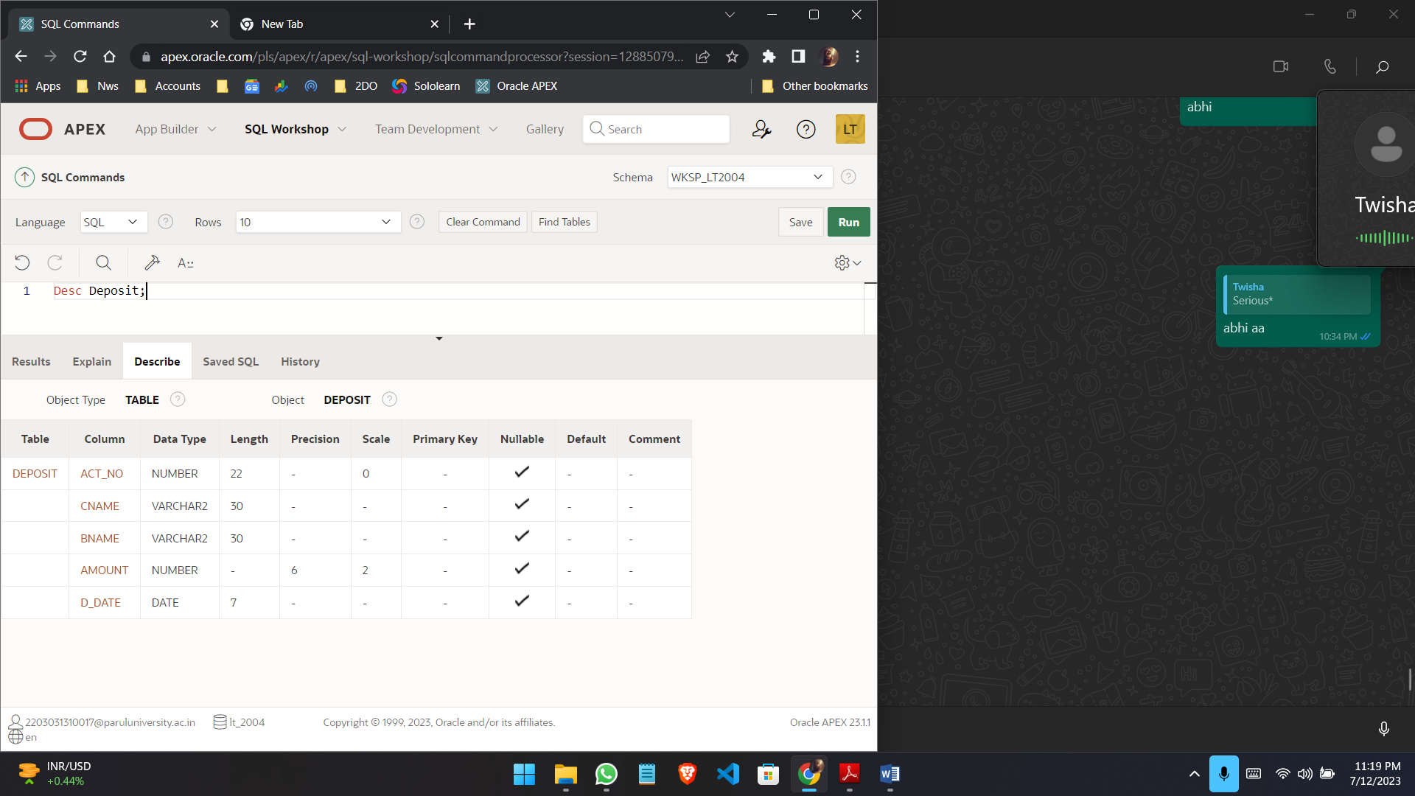

**Query:**

desc Branch;

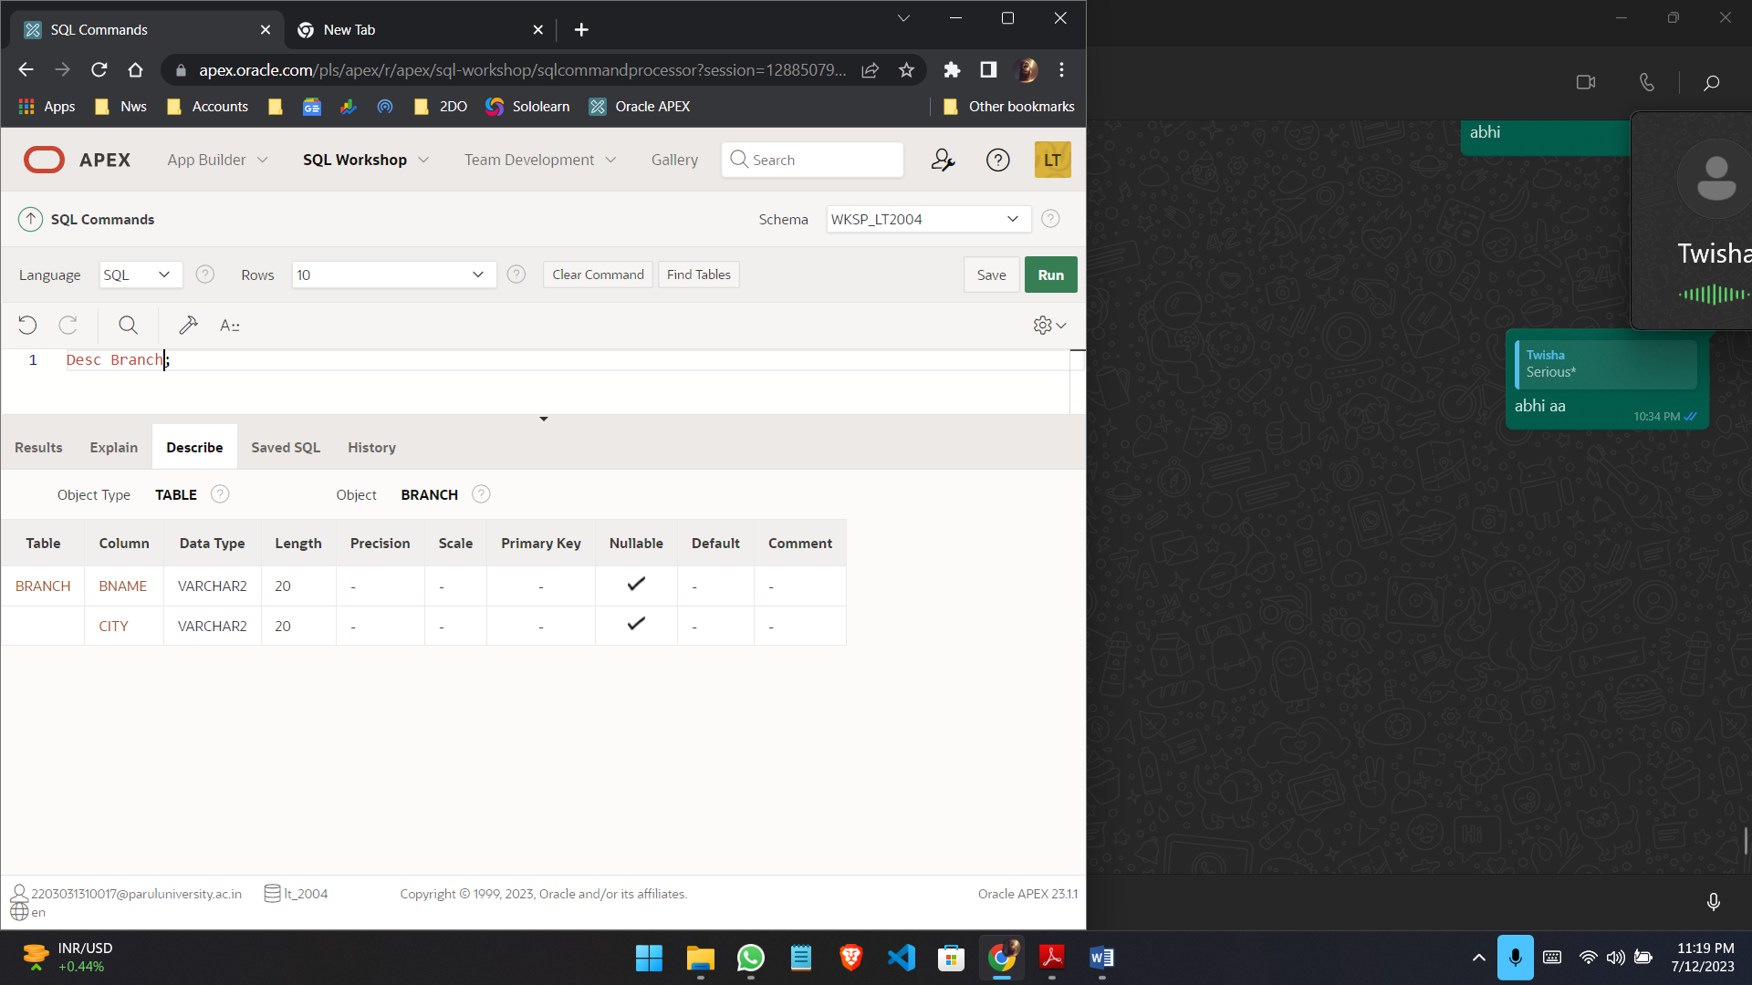

**(2) Describe borrow, customers.**

**Query:**

desc Borrow;

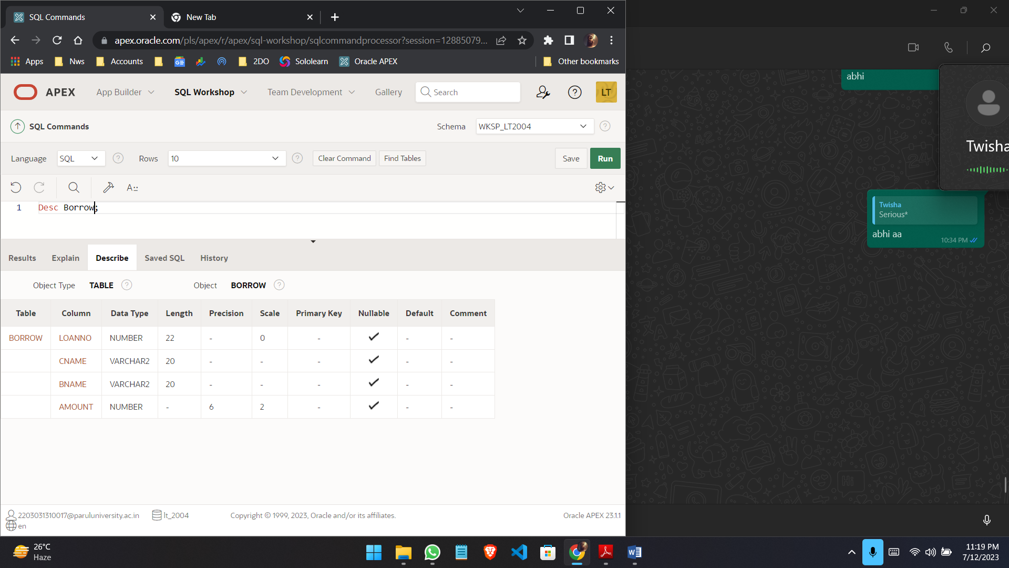

**Query:**

desc Customers;

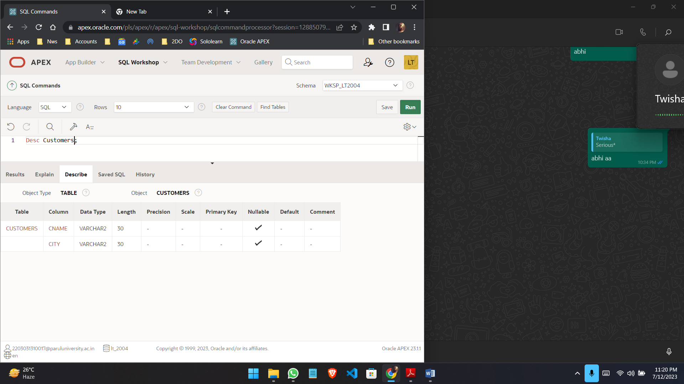

**(3) List all data from table DEPOSIT.**

**Query:**

select * from Deposit;

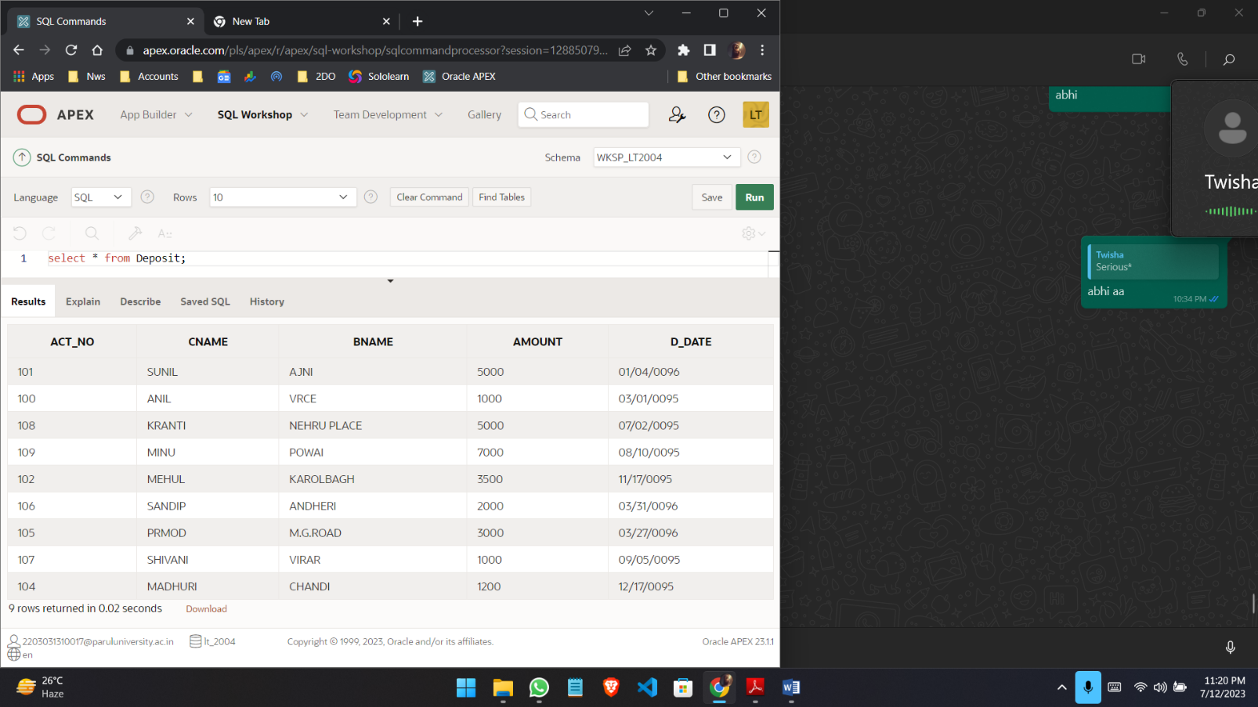

**(4) List all data from table BORROW.**

**Query:**

select * from Borrow;

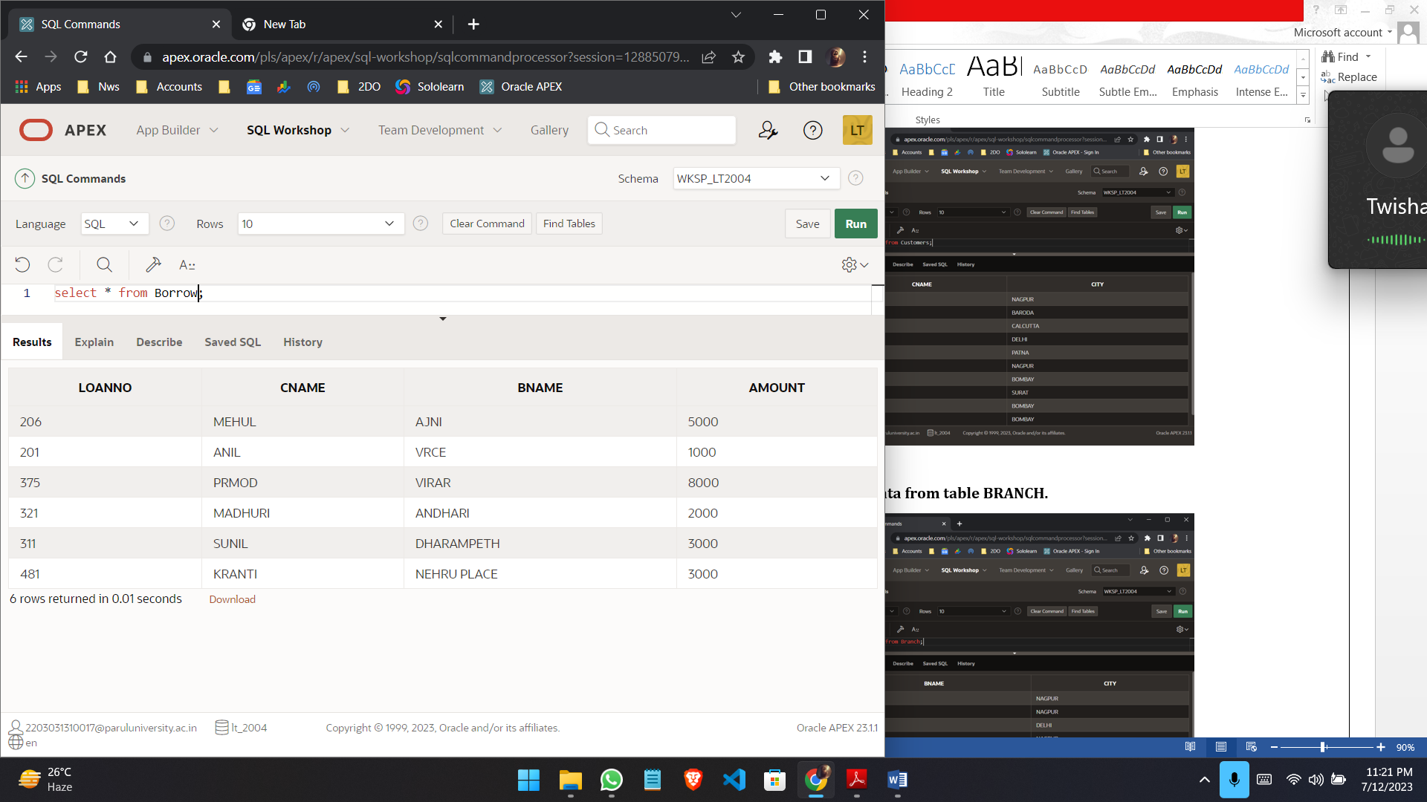

**(5) List all data from table CUSTOMERS.**

**Query:**

select * from Customers;

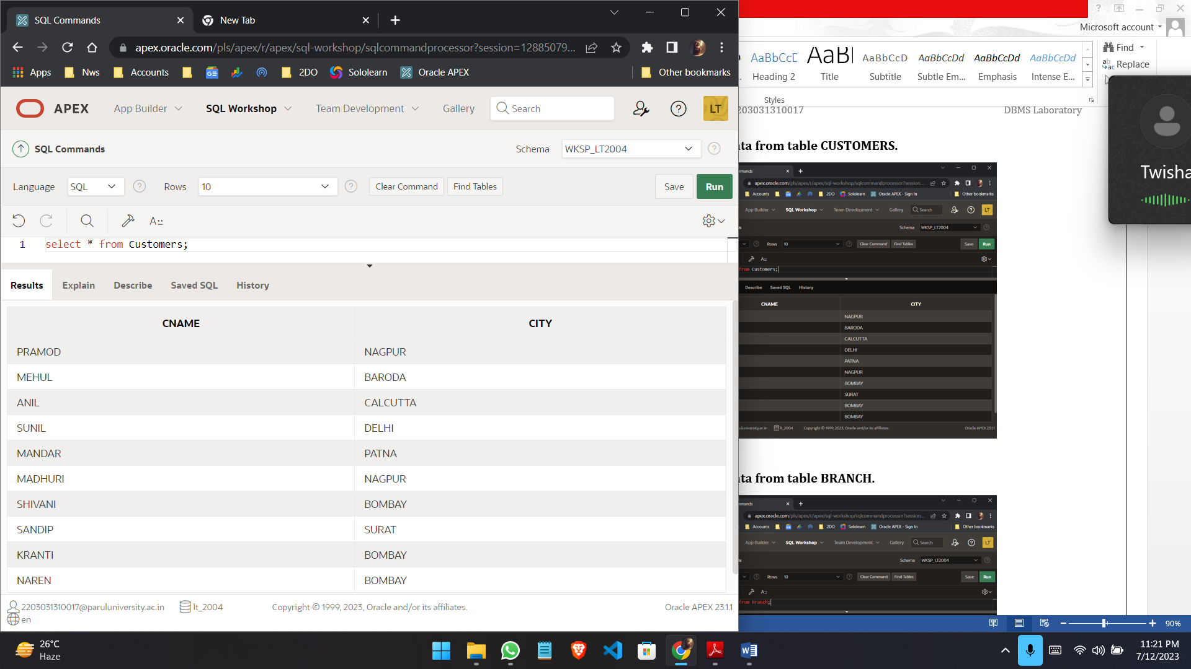

**(6) List all data from table BRANCH.**

**Query:**

select * from Branch;

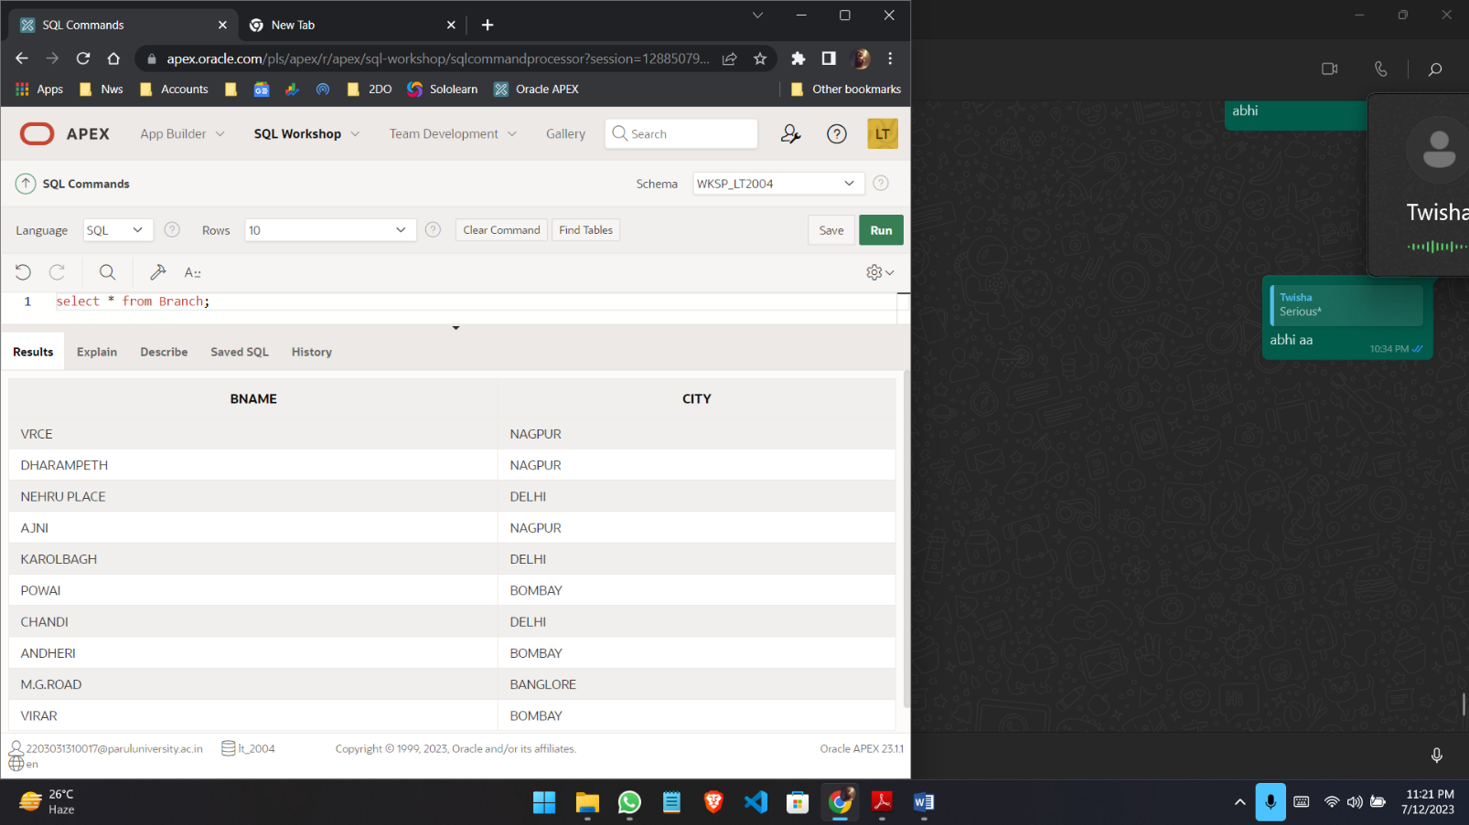

**(7) Give account no and amount of depositors.**

**Query:**

select Act_no, Amount from Deposit;

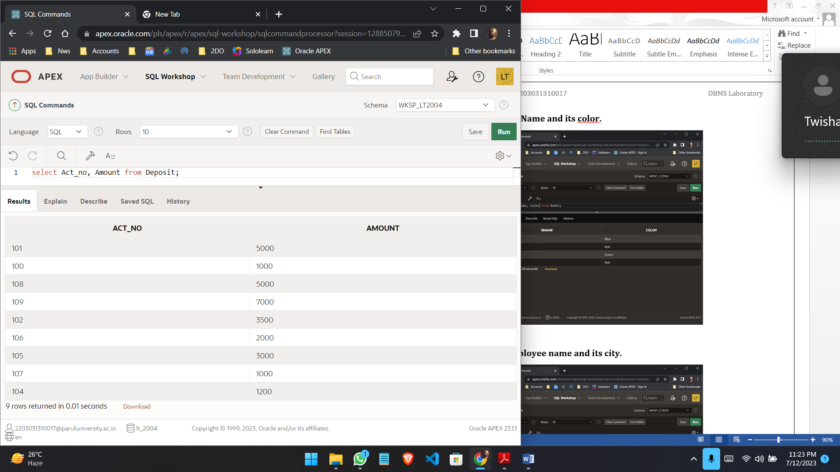

**(8) List all data from SAILORS.**

**Query:**

select * from Sailors;

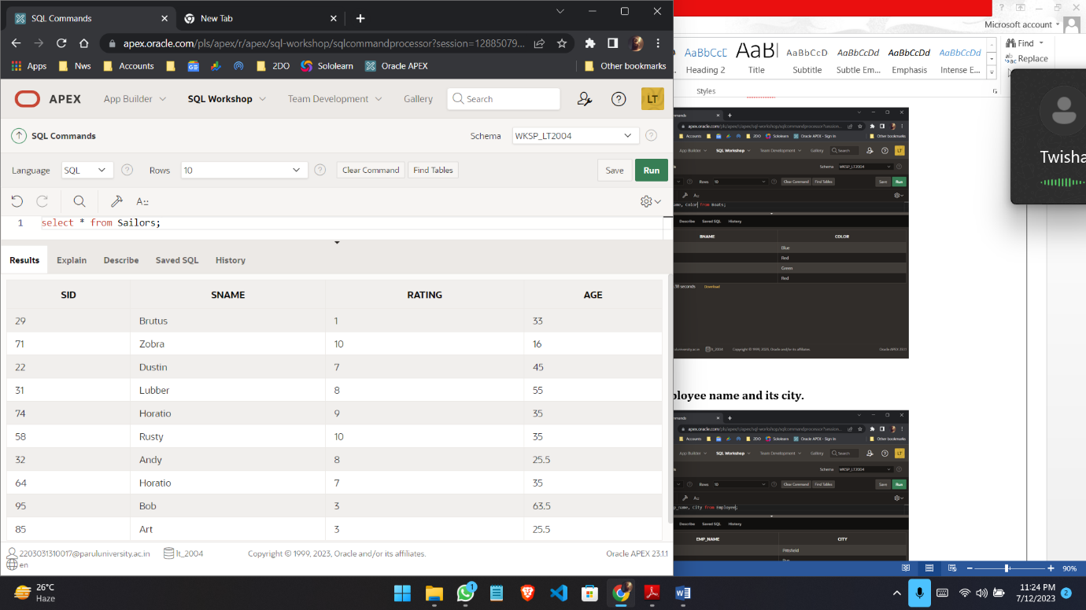

**(9) List Boat Name and its color.**

**Query:**

select Bname, Color from Boats;

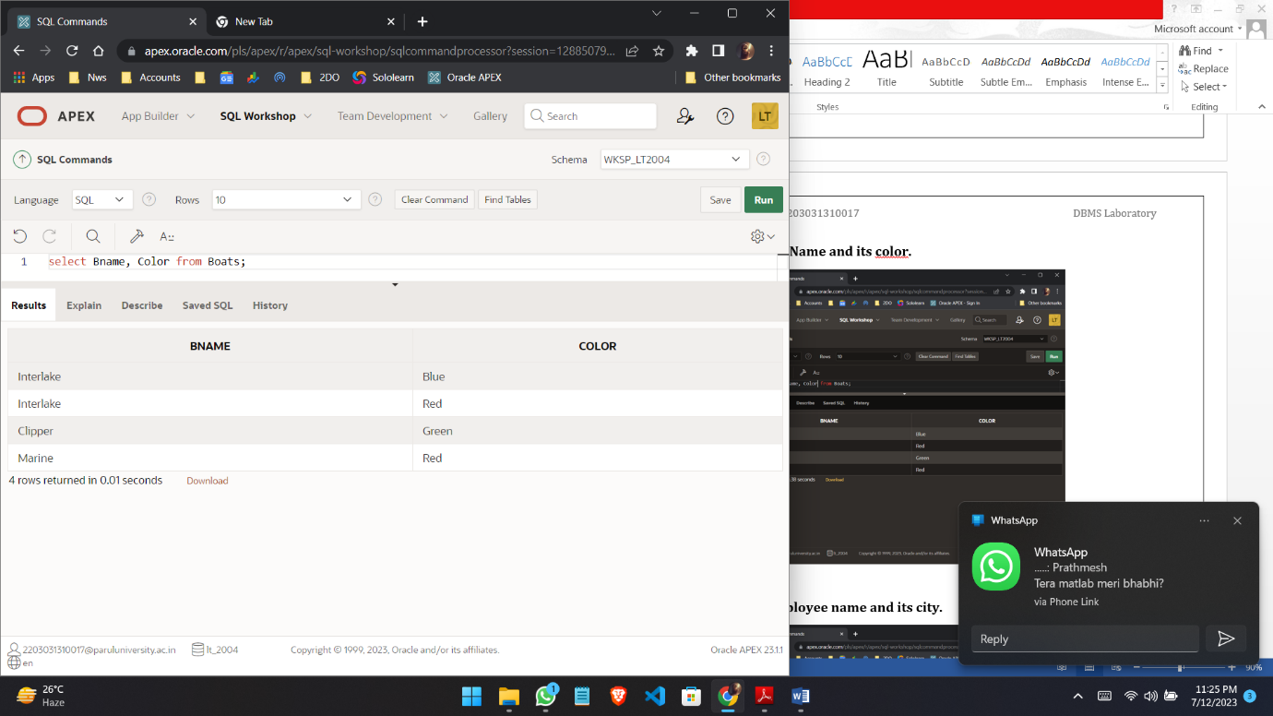

**(10) List Employee name and its city.**

**Query:**

select Emp_name, City from Employee;

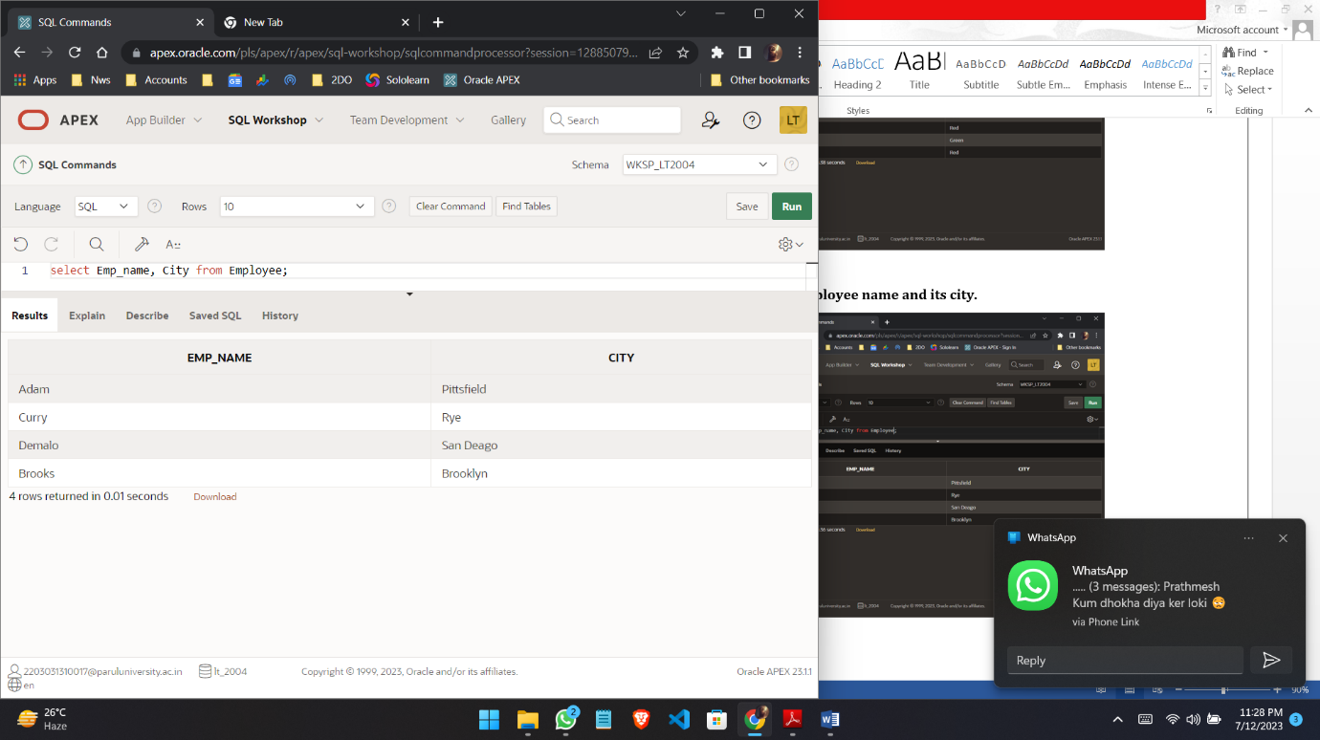

**(11) List all the details of Clients.**

**Query:**

select * from Client;

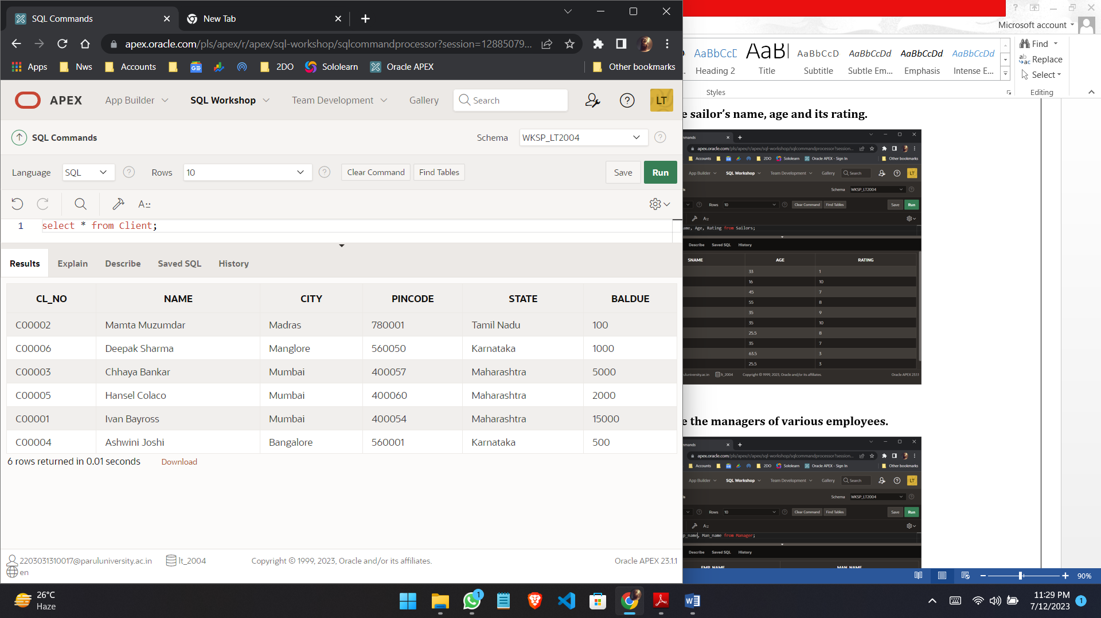

**(12) Describe various products and its price.**

**Query:**

select Dscr, Sell_Price, Cost_Price from Product;

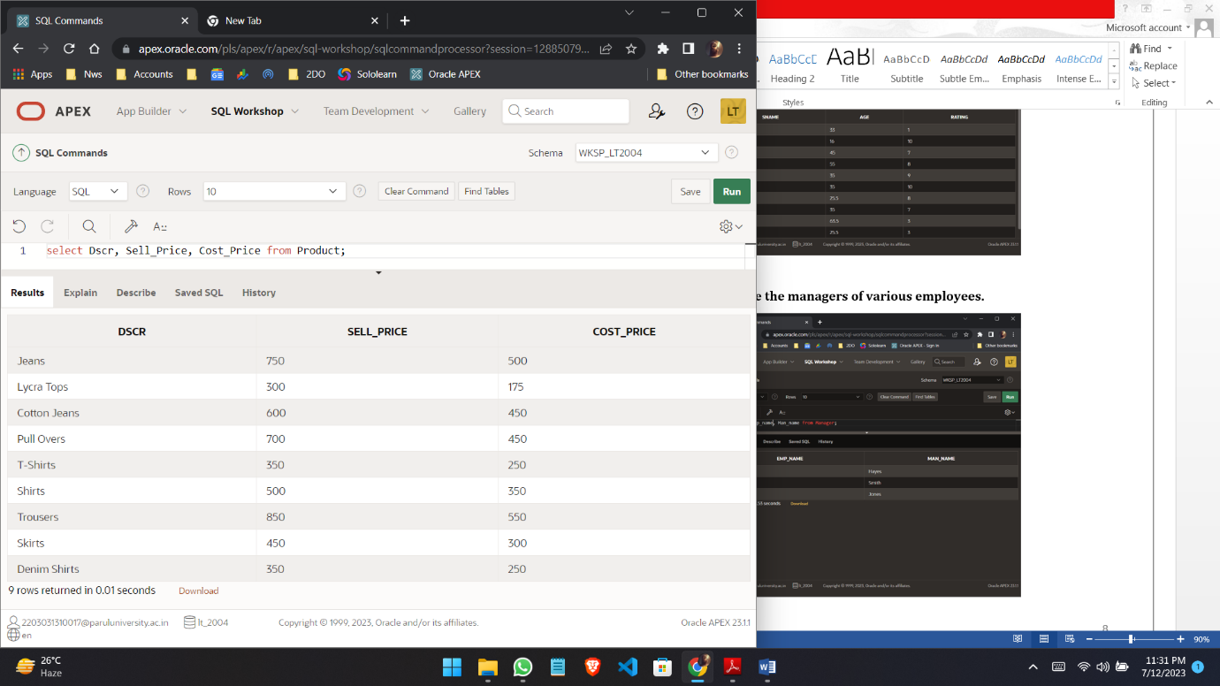

**(13) Describe sailor’s name, age and its rating.**

**Query:**

select Sname, Age, Rating from Sailors;

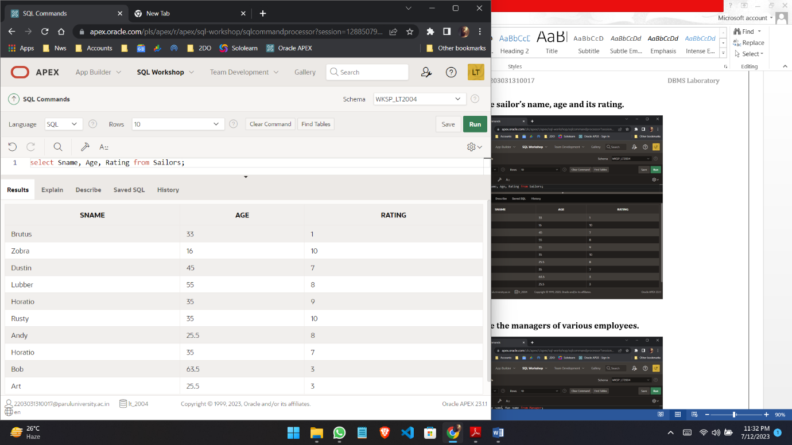

**(14) Describe the managers of various employees.**

**Query:**

select Emp_name, Man_name from Manager;

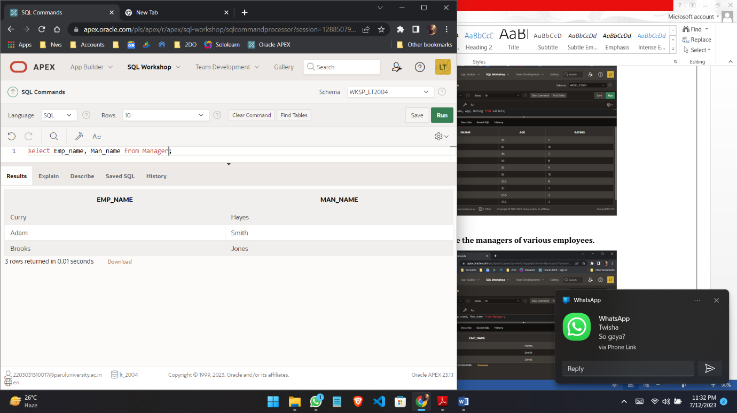

**(15) Describe the details of Loan for customers.**

**Query:**

select Cname, Amount from Borrow;

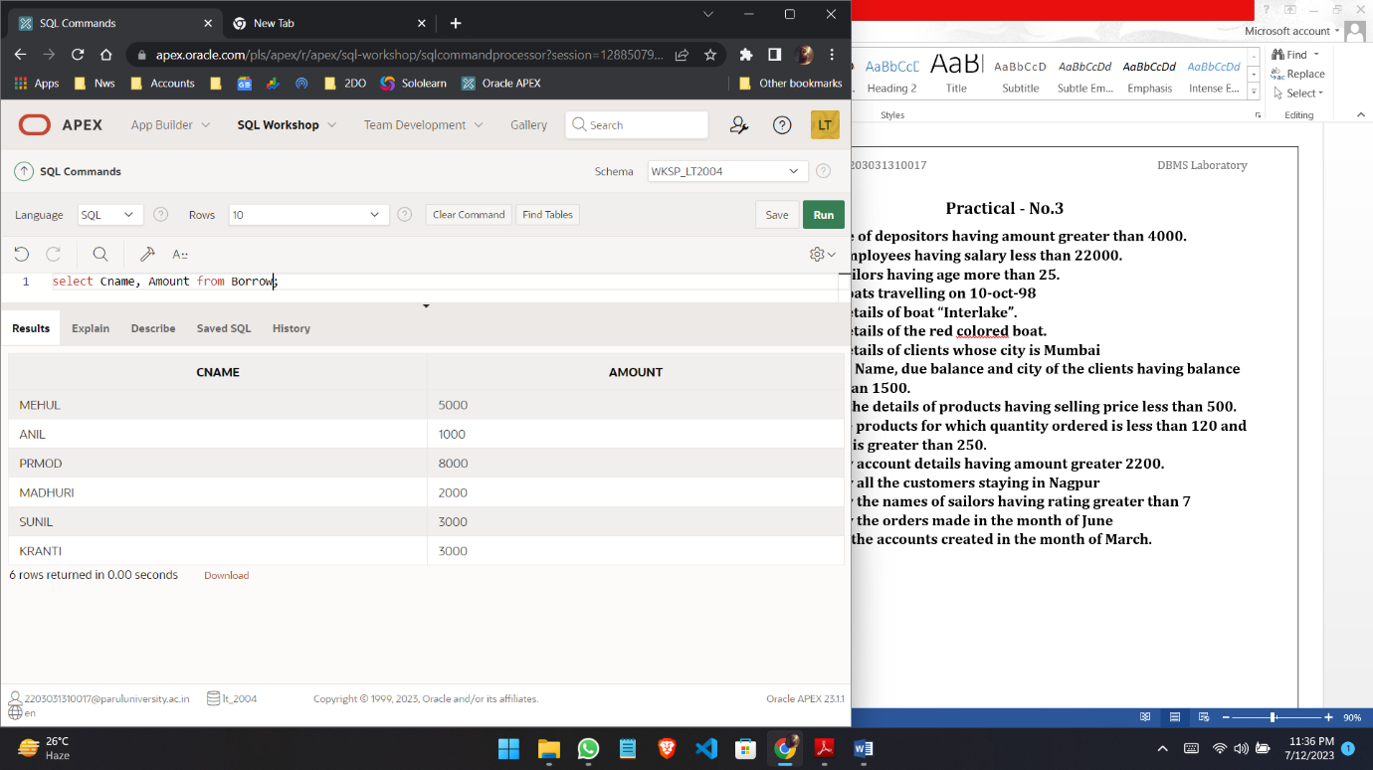

**(16) Describe the date of travel of various sailors.**

**Query:**

select Day from Reserves;

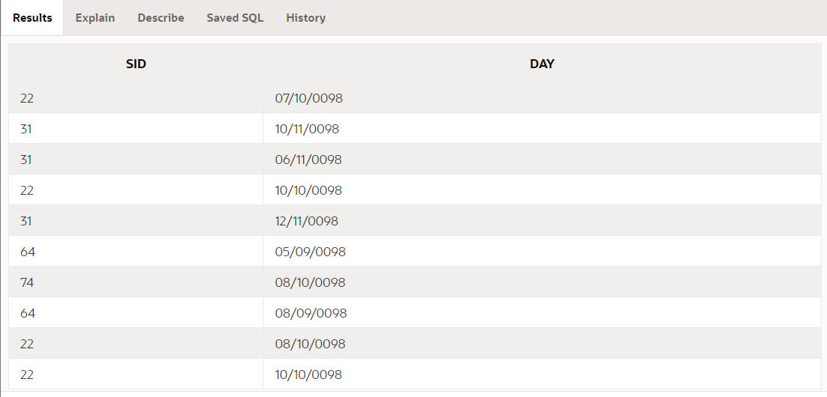

**Practical - No.4**

1. **Give name of depositors having amount greater than 4000.**

**Query:**

select Cname from Deposit where Amount > 4000;

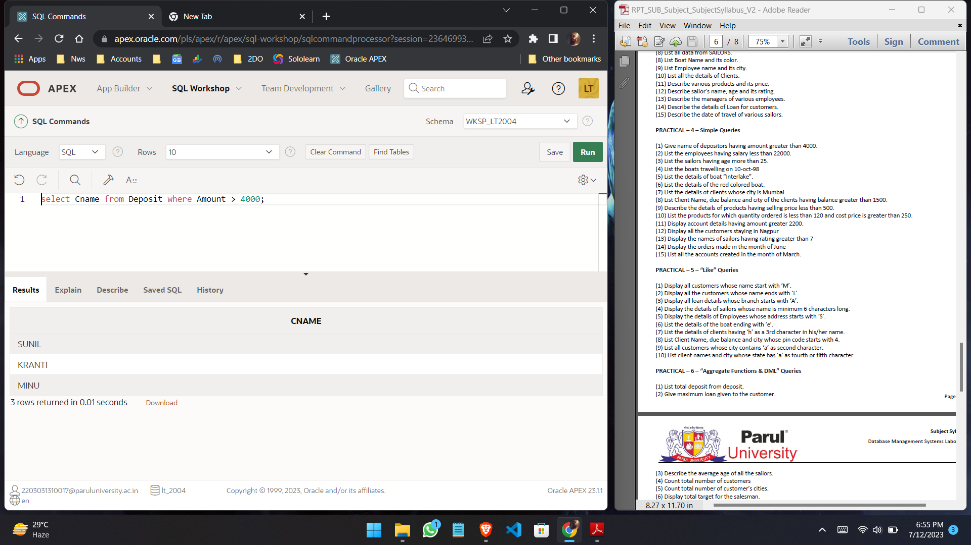

1. **List the employees having salary less than 22000.**

**Query:**

select Emp_name from Work where Salary < 22000;

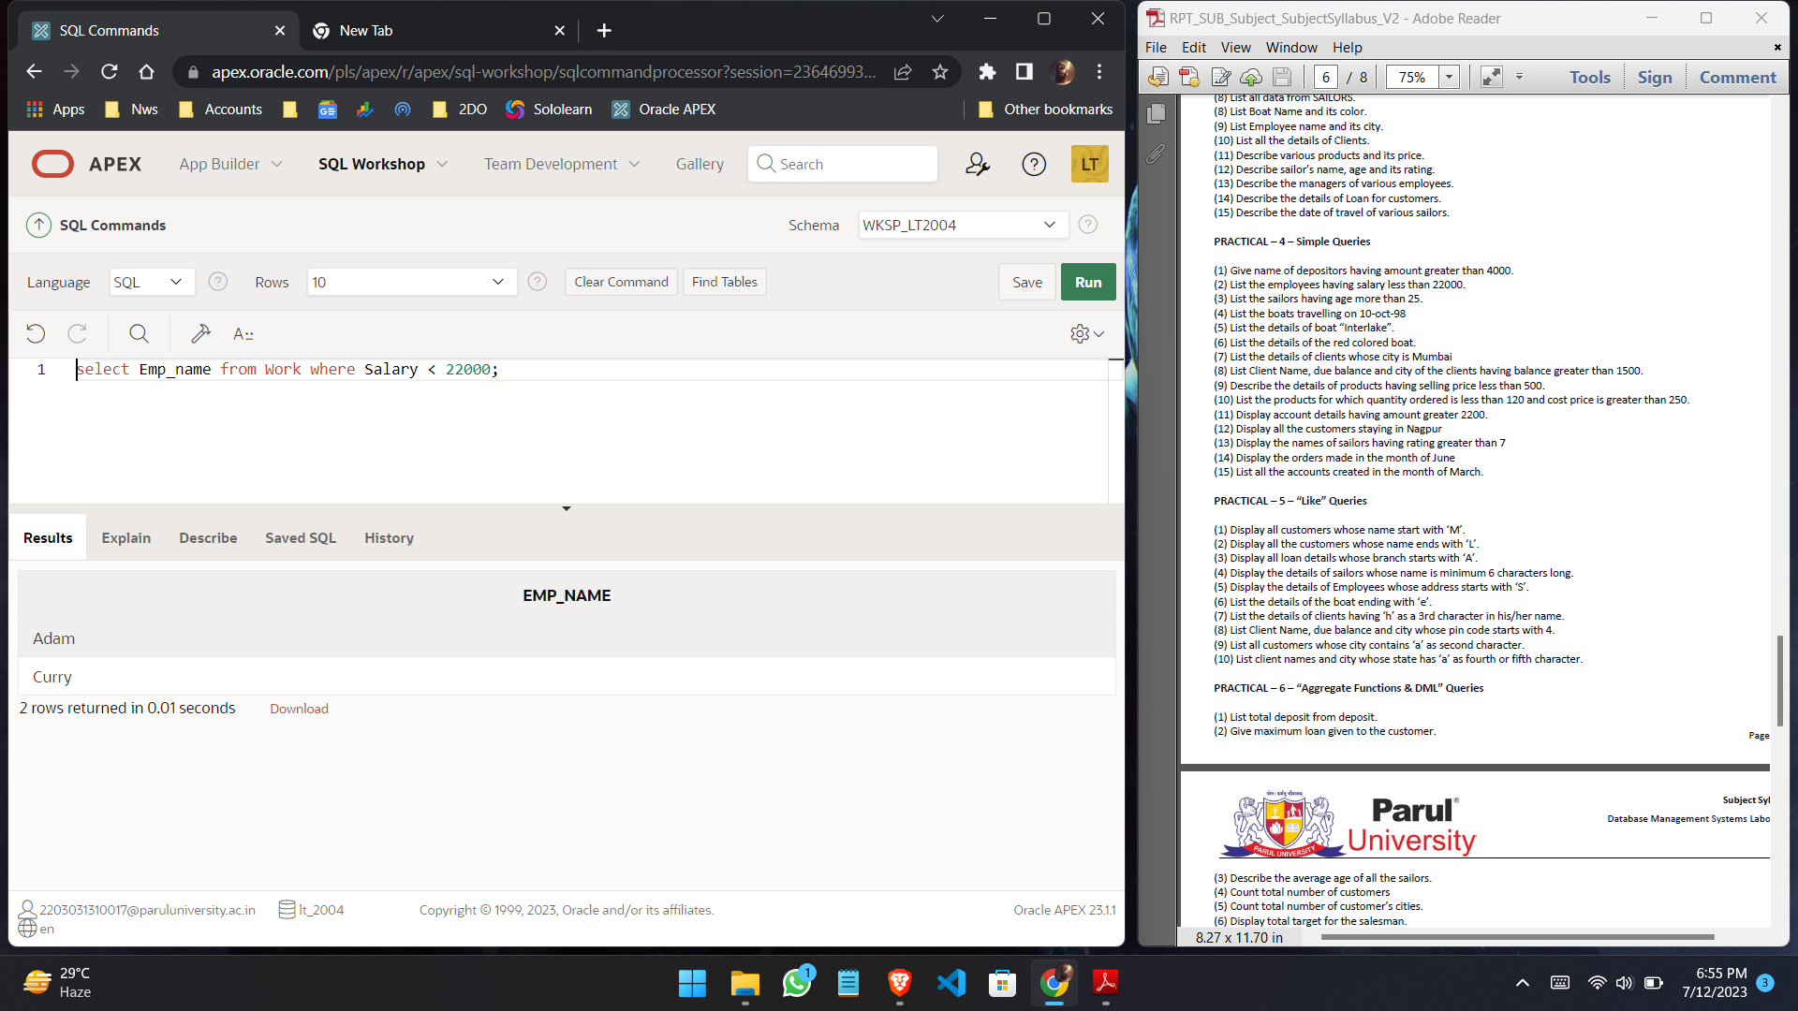

1. **List the sailors having age more than 25.**

**Query:**

select Sname from Sailors where Age > 25;

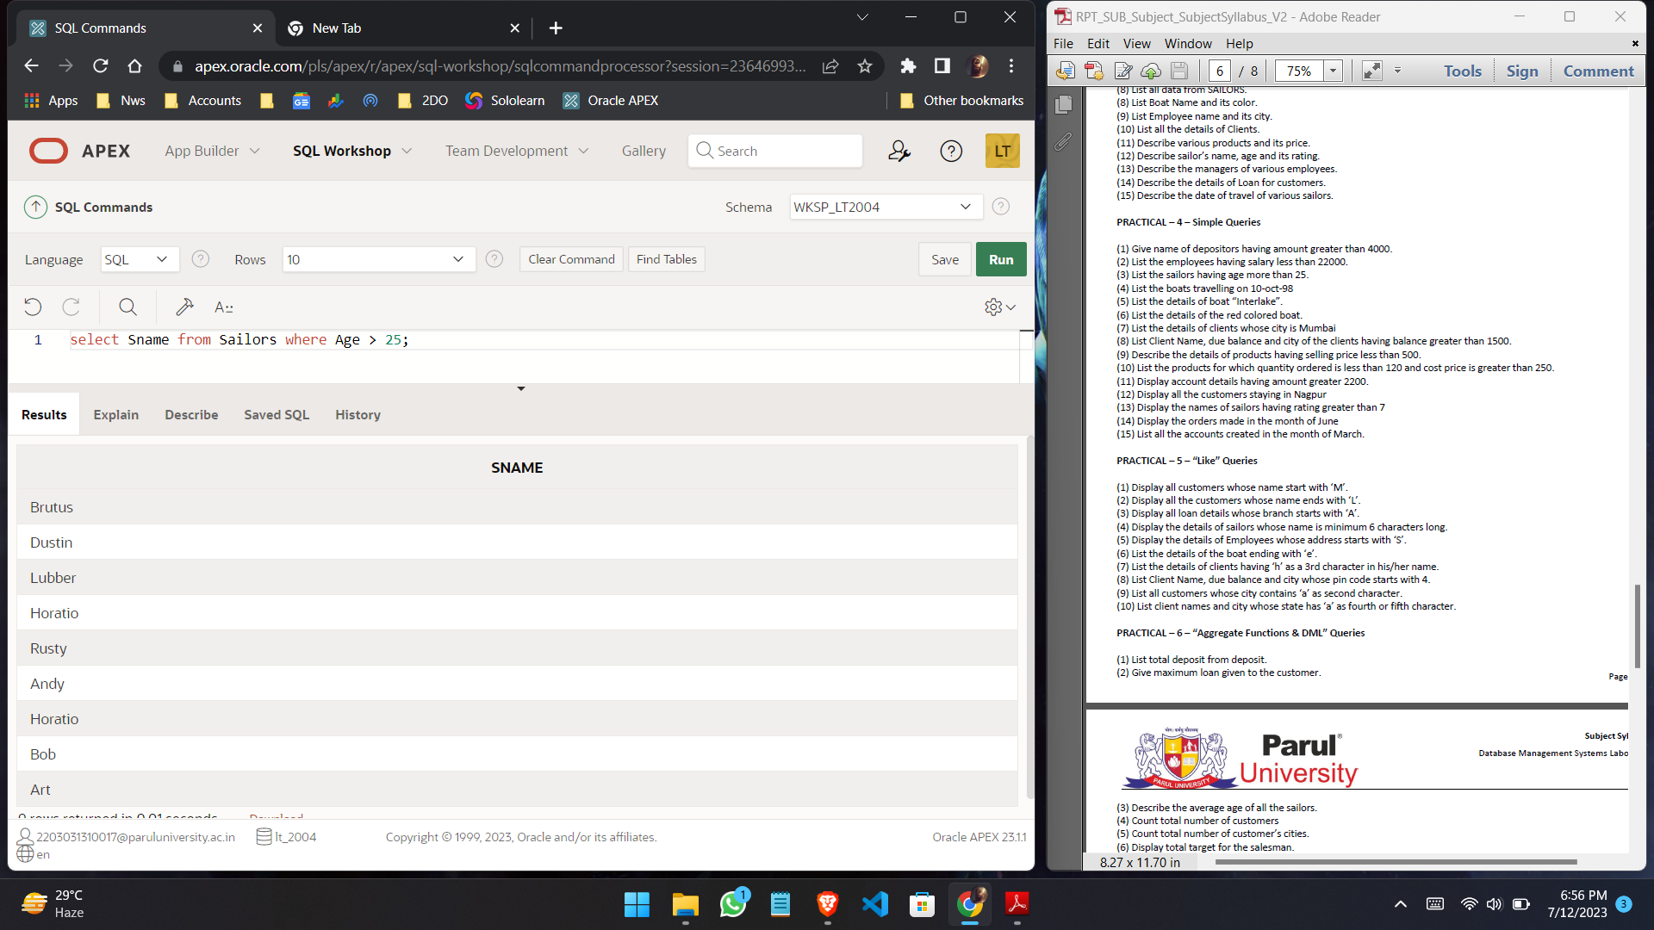

1. **List the boats travelling on 10-oct-98**

**Query:**

select Bid from Reserves where Day = ’10-10-98’;

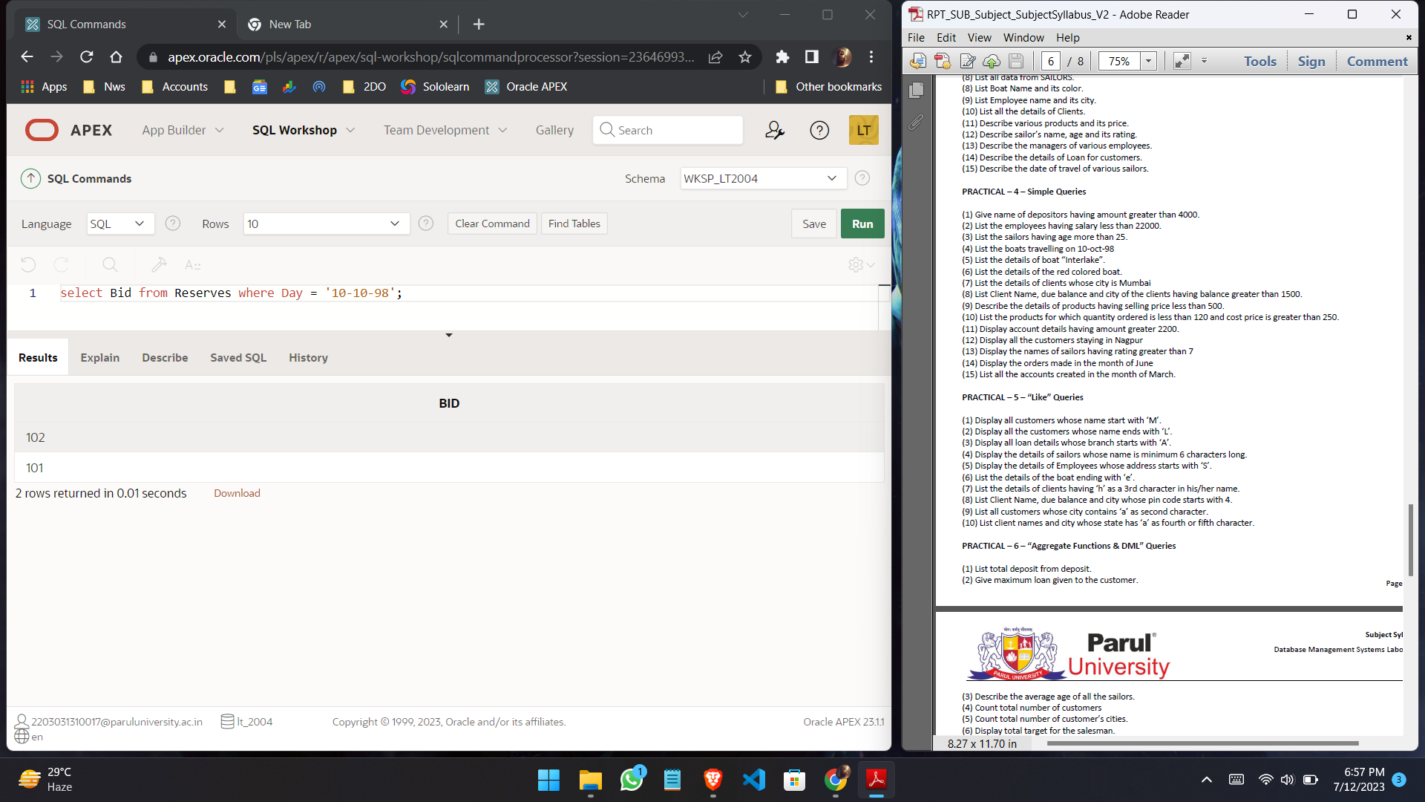

1. **List the details of boat “Interlake”.**

**Query:**

select * from Boats where Bname = ‘Interlake’;

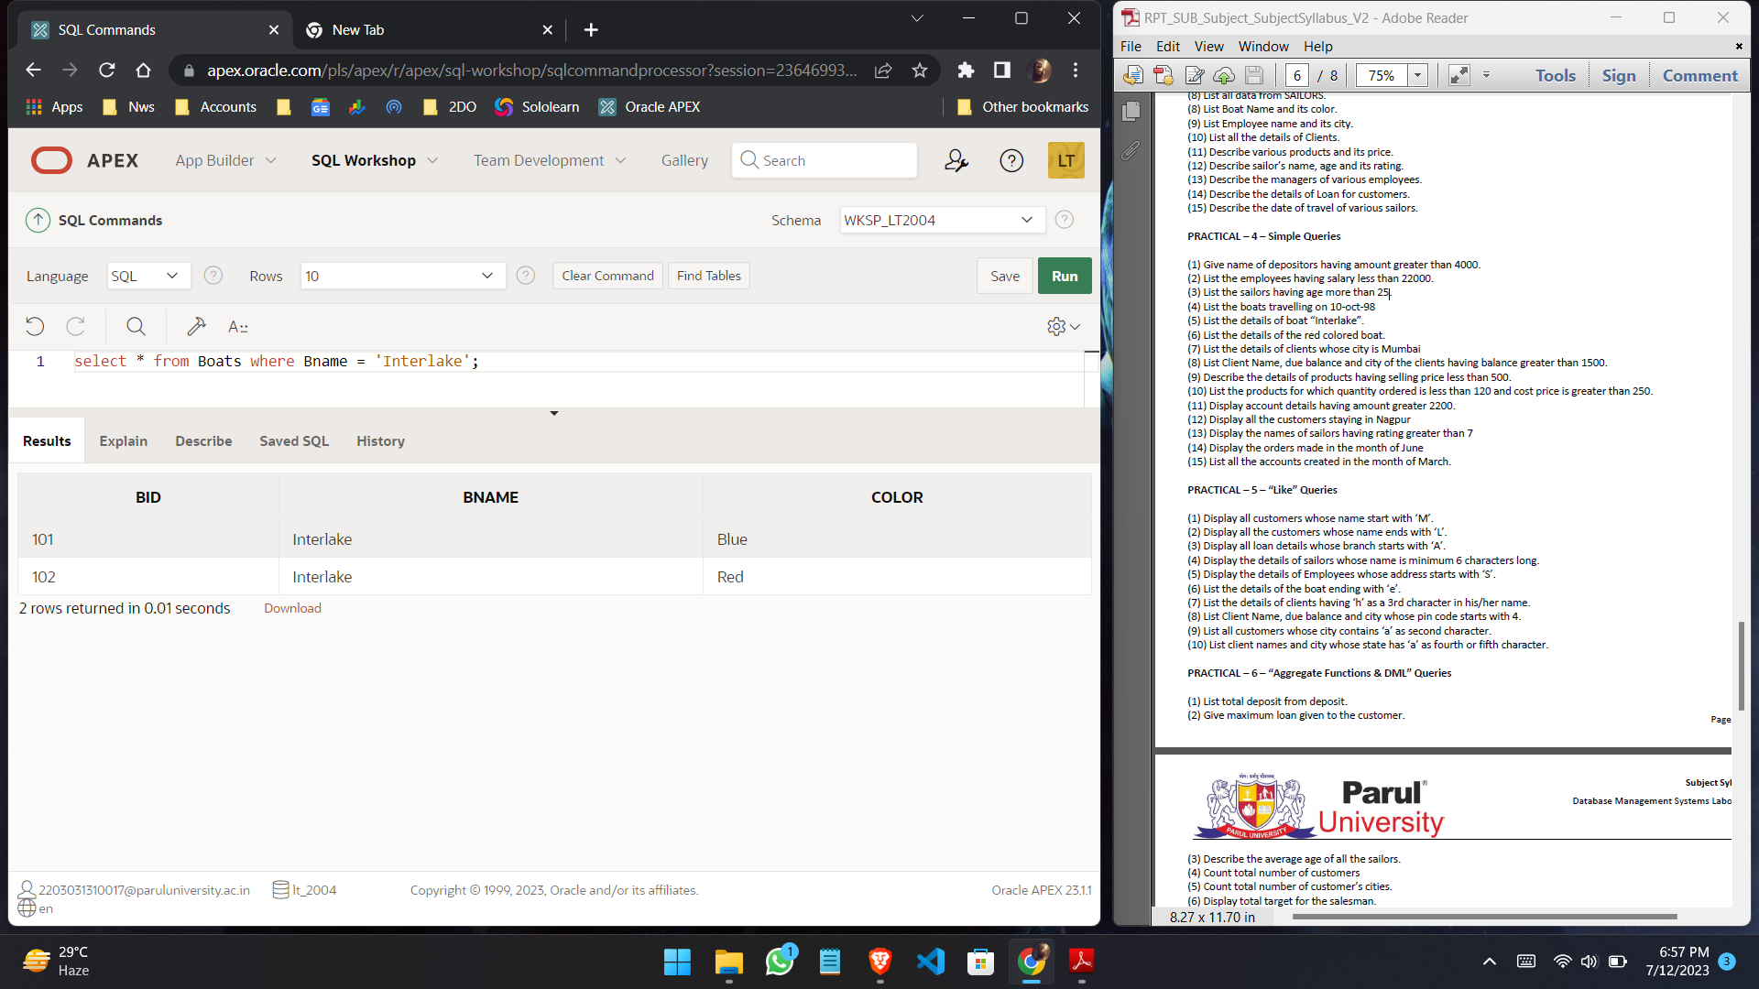

1. **List the details of the red colored boat.**

**Query:**

select * from Boats where Color = ‘Red’;

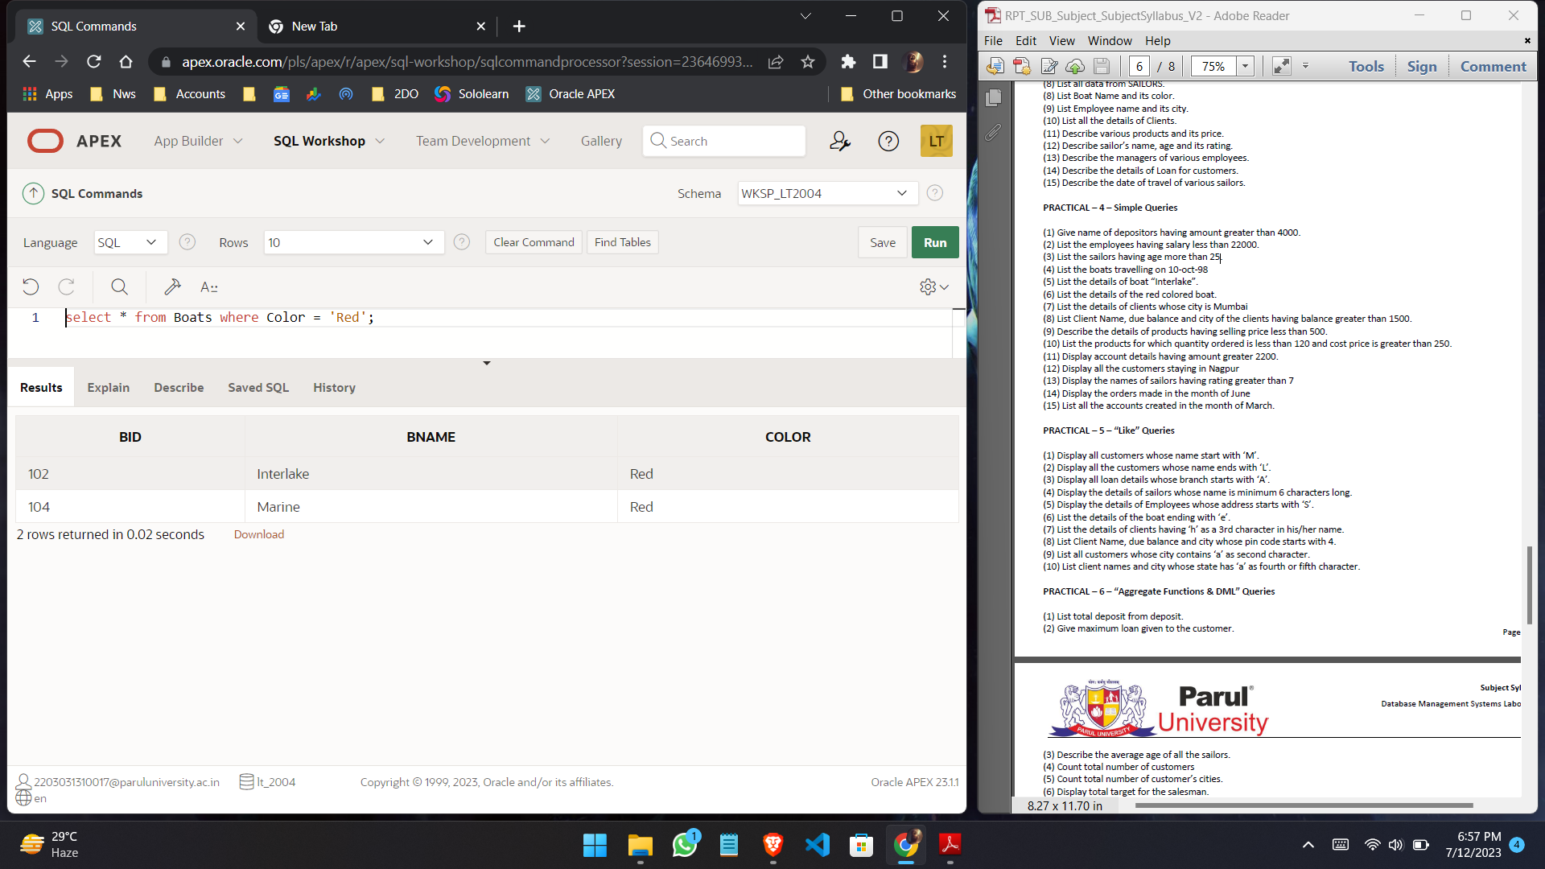

1. **List the details of clients whose city is Mumbai**

**Query:**

select * from Client where City = ‘Mumbai’;

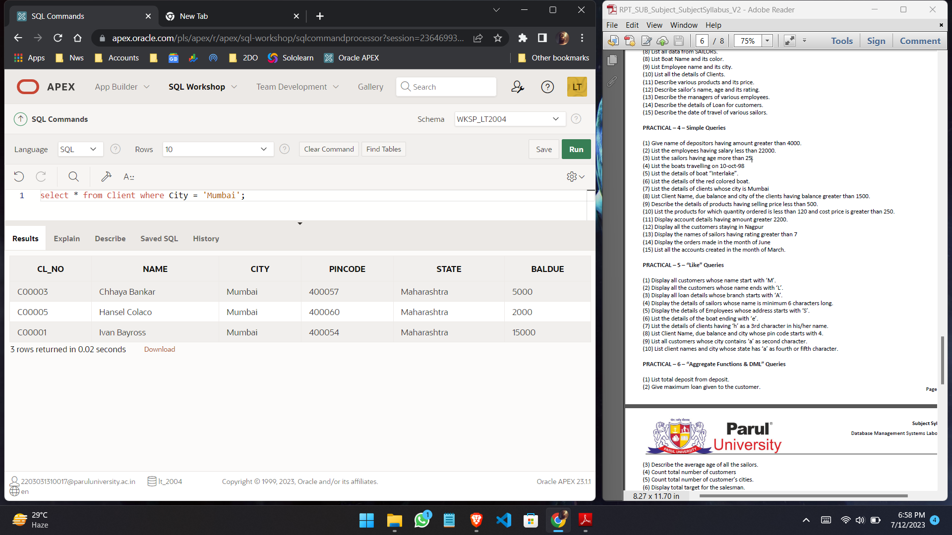

1. **List Client Name, due balance and city of the clients having balance greater than 1500.**

**Query:**

select Name, Baldue, City from Client where Baldue > 1500;

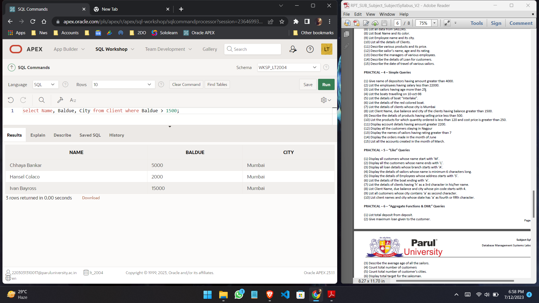

1. **Describe the details of products having selling price less than 500.**

**Query:**

select * from Product where Sell_Price< 500;

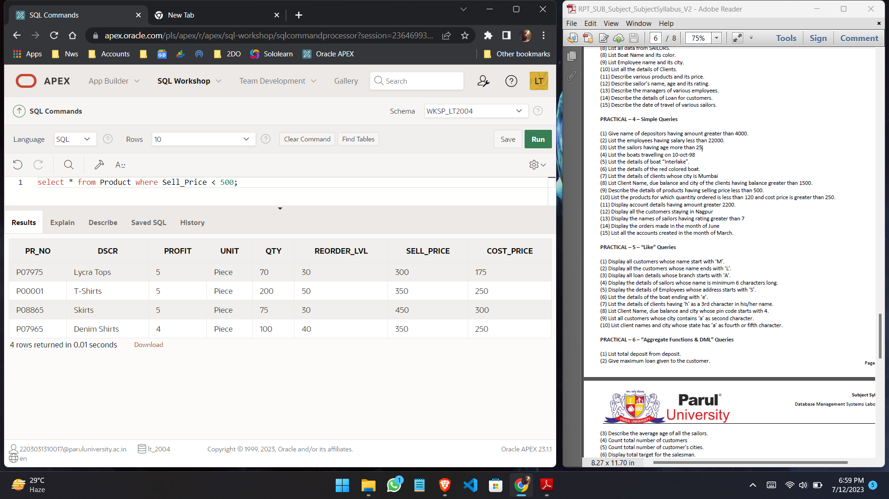

1. **List the products for which quantity ordered is less than 120 and cost price is greater than 250.**

**Query:**

select Dscr from Product where Qty < 120 and cost_Price > 250;

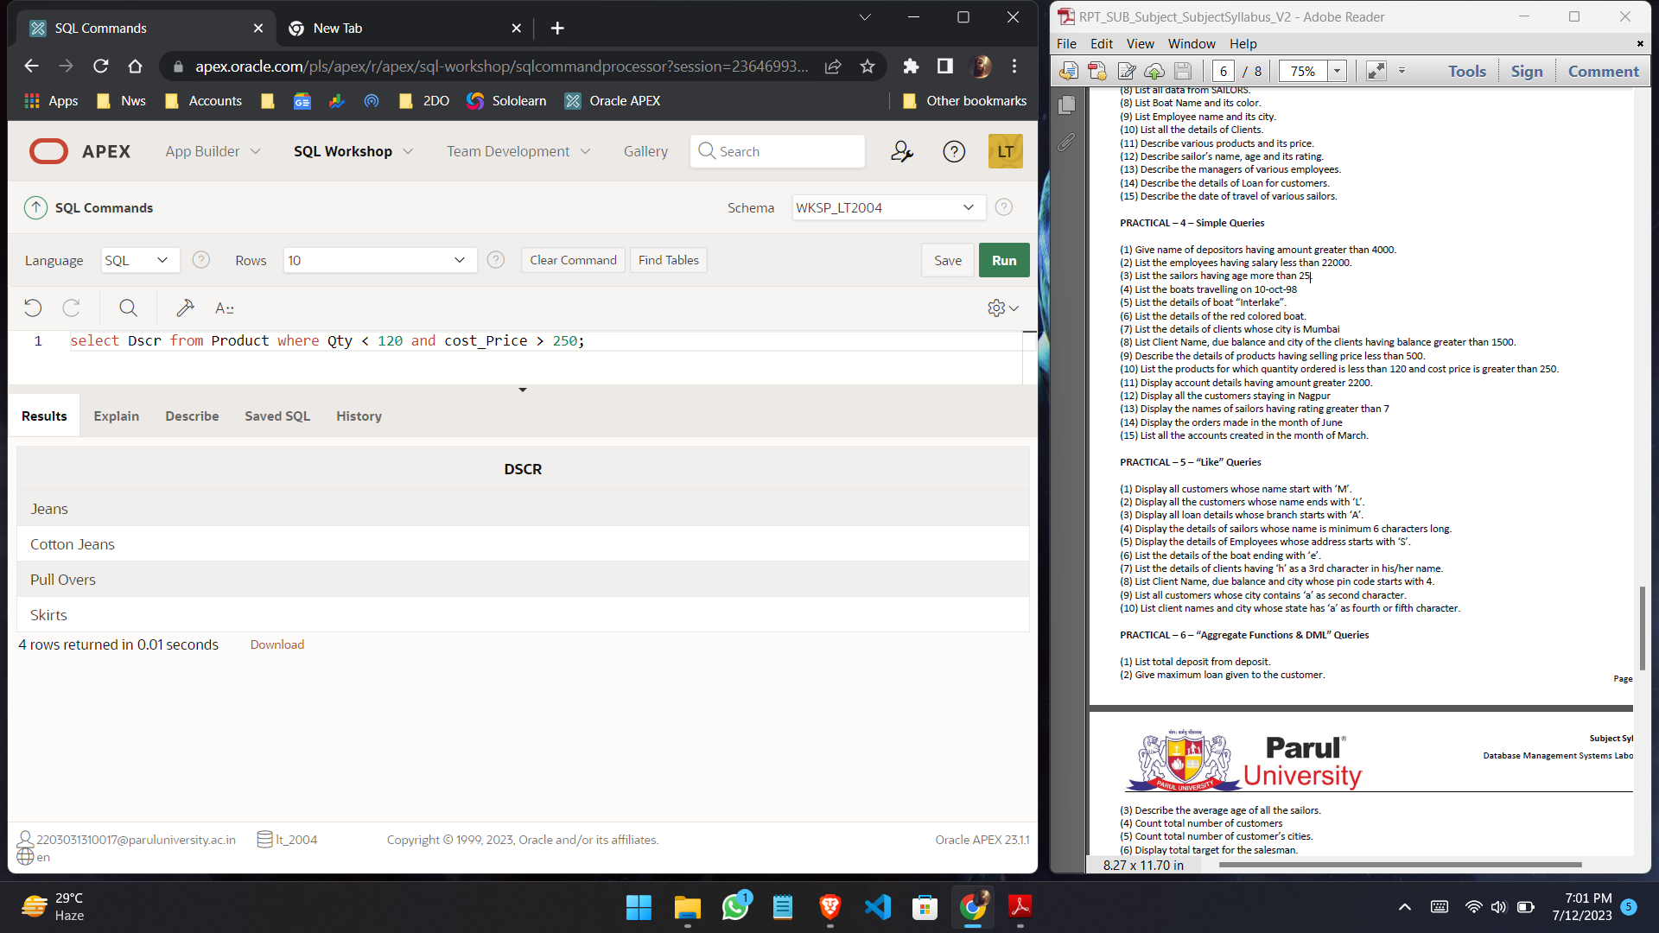

1. **Display account details having amount greater 2200.**

**Query:**

select * from Deposit where Amount > 2200;

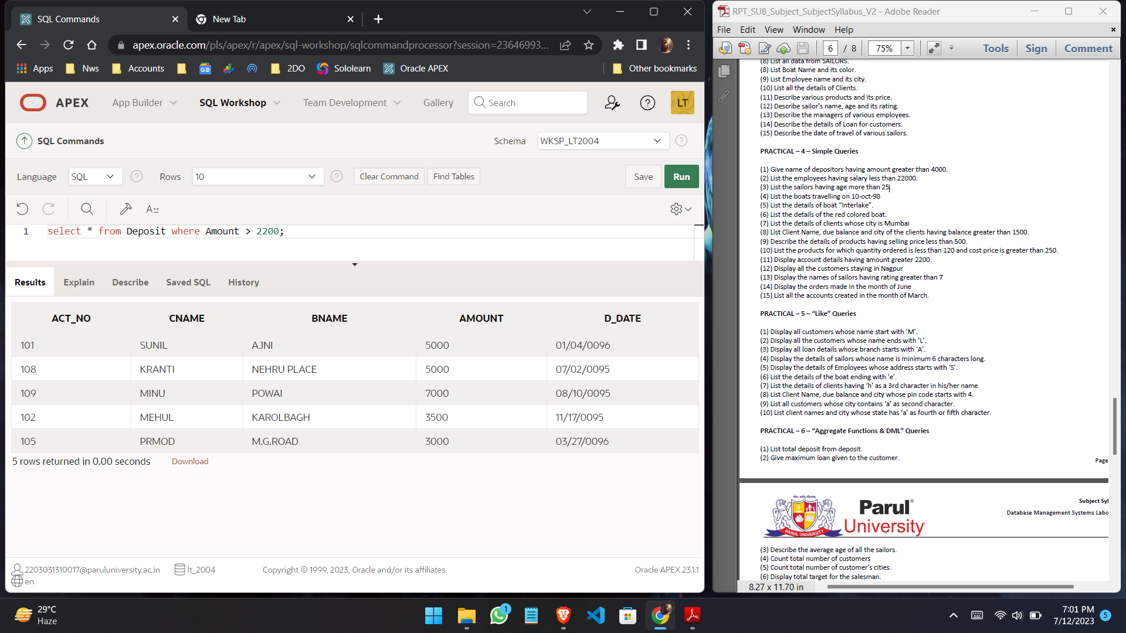

1. **Display all the customers staying in Nagpur**

**Query:**

select Cname from Customers where City = ‘NAGPUR’;

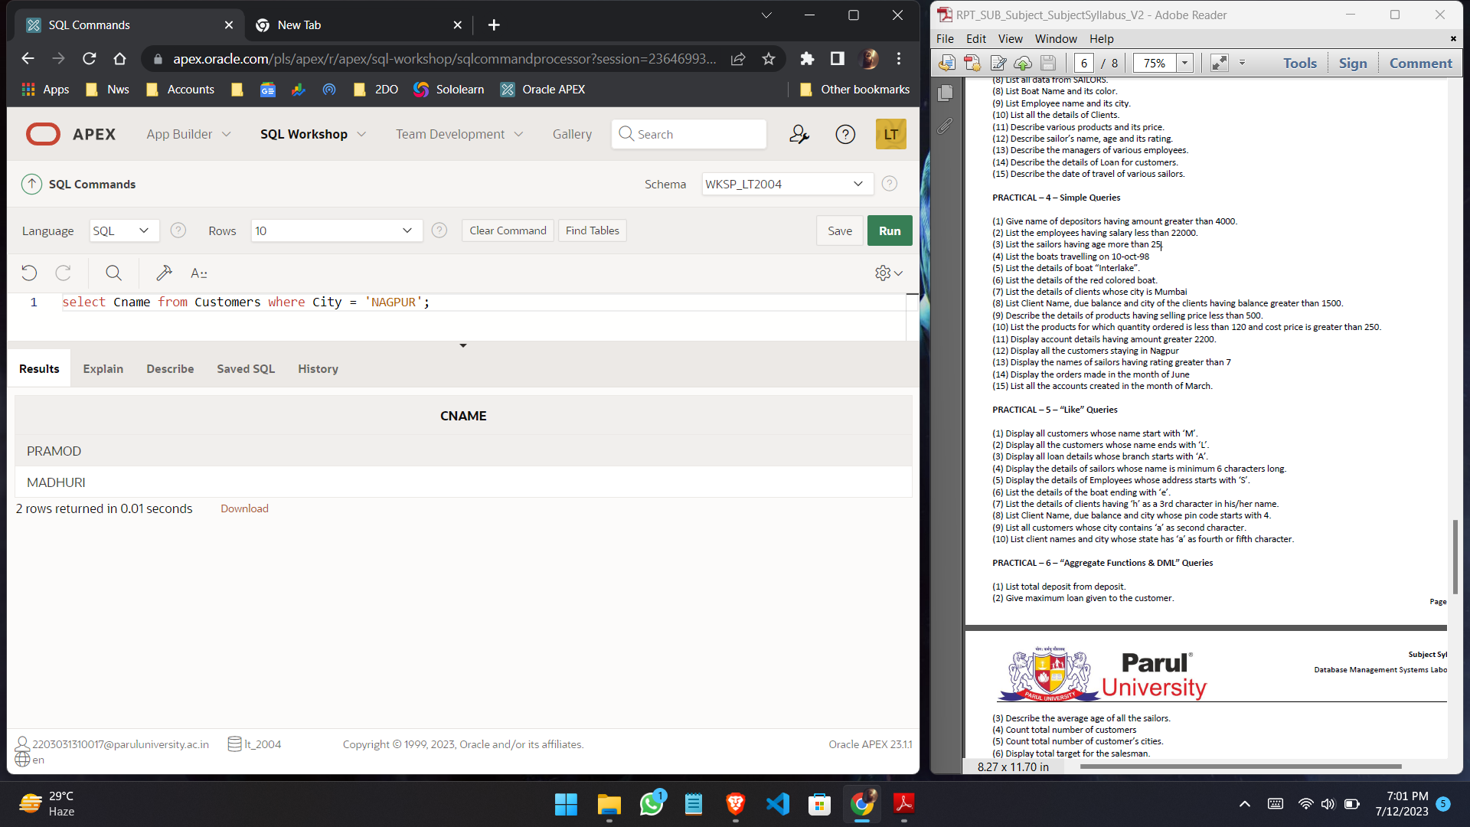

1. **Display the names of sailors having rating greater than 7**

**Query:**

select Sname from Sailors where Rating > 7;

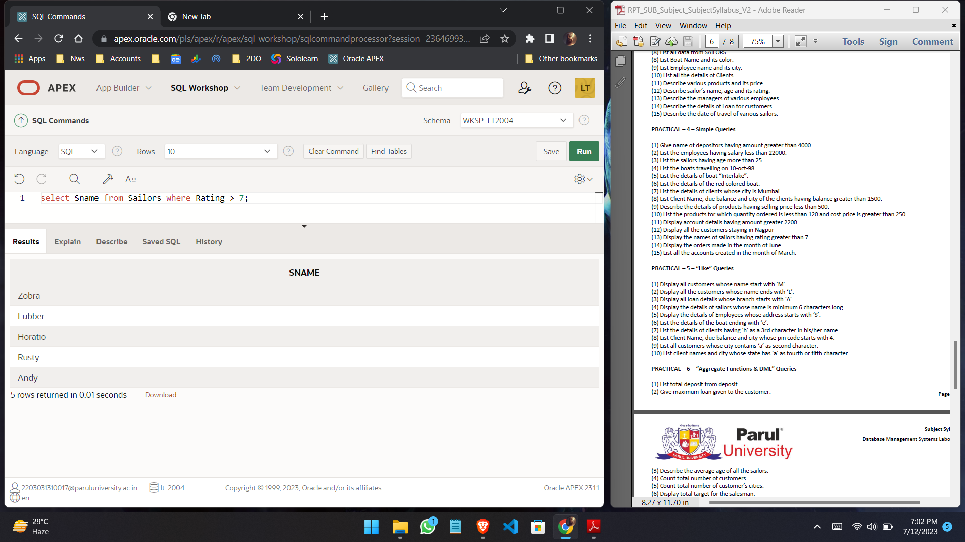

1. **Display the orders made in the month of June**

**Query:**

select * from Salesorder where O_dat >= ‘06-01-04’ and O_dat <= ‘06-30-04’;

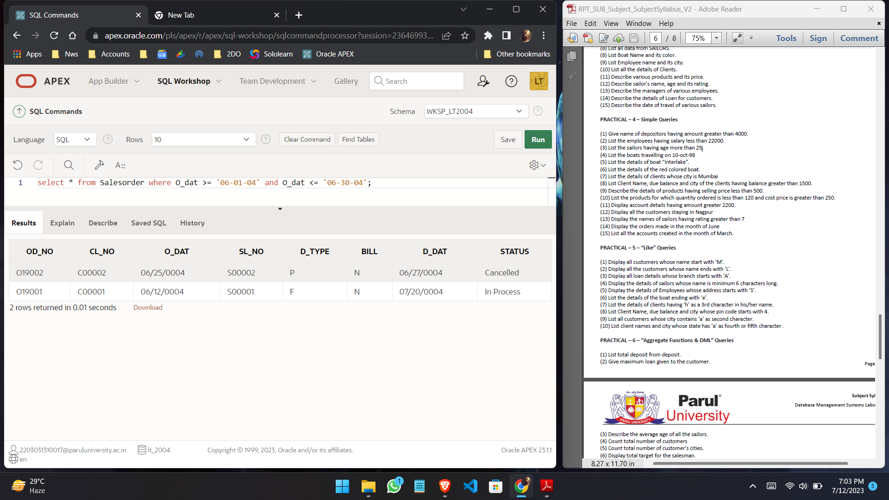

1. **List all the accounts created in the month of March.**

**Query:**

select Act_no from Deposit where D_date = ‘03-01-95’ or D_date = ‘03-27-96’ or D_date = ‘03-31-96’;

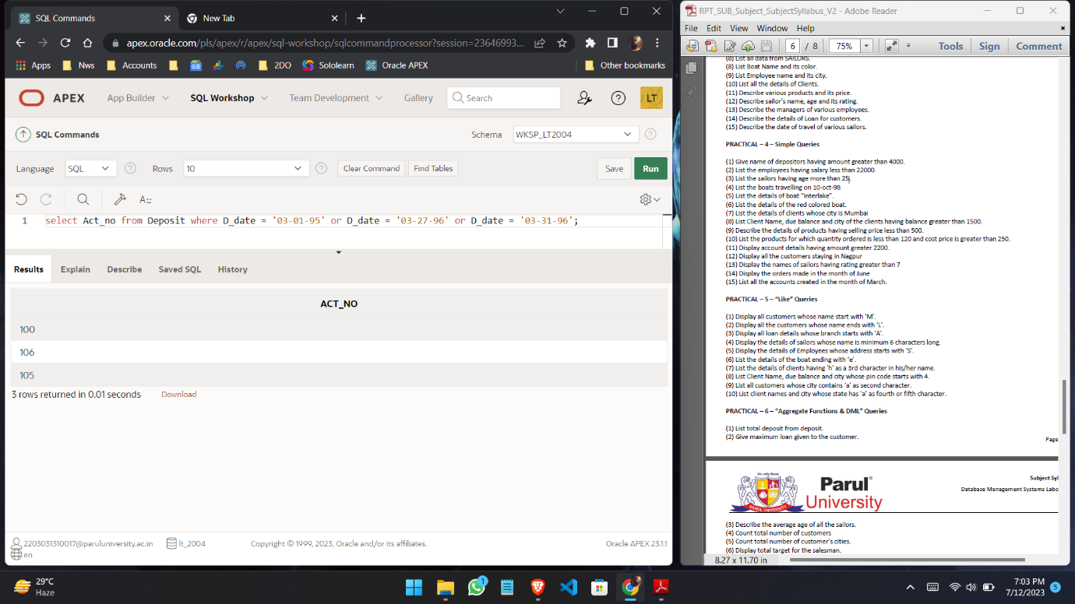

**Practical - No.5**

1. **Display all customers whose name start with ‘M’.**

**Query:**

select * from customers where cname like ‘M%’;

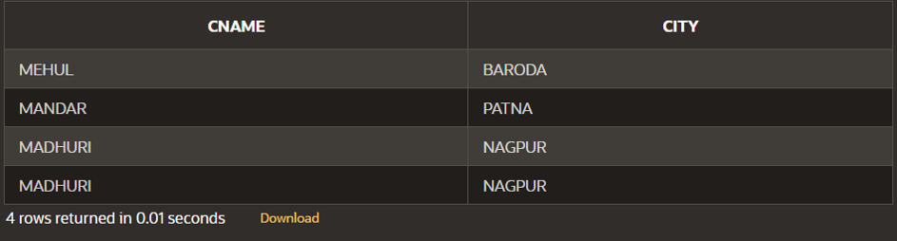

1. **Display all the customers whose name ends with ‘L’.**

**Query:**

select * from customers where cname like ‘%L’;

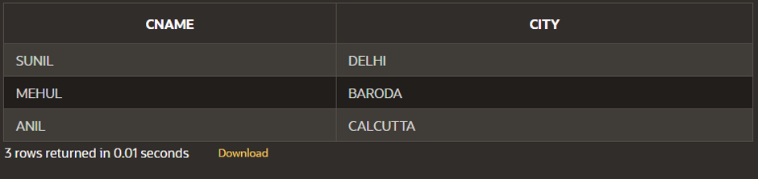

1. **Display all loan details whose branch starts with ‘A’.**

**Query:**

select * from branch where bname like ‘A%’;

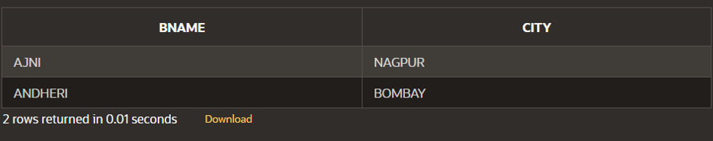

1. **Display the details of sailors whose name is minimum 6 characters long.**

**Query:**

select* from sailors where sname like ‘______%’;

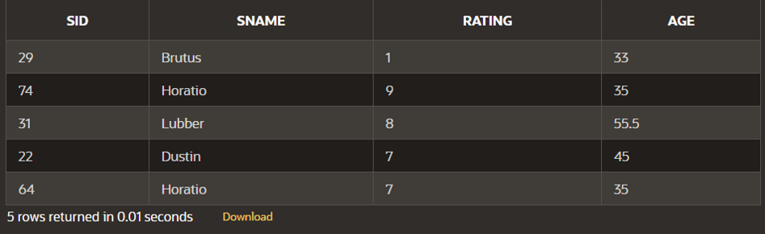

1. **Display the details of Employees whose address starts with ‘S’.**

**Query:**

select * from employee where city like ‘S%’;

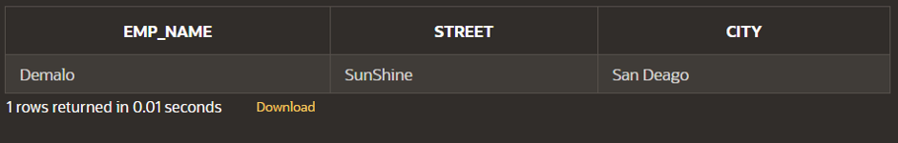

1. **List the details of the boat ending with ‘e’.**

**Query:**

select * from boats where bname like ‘%e’;

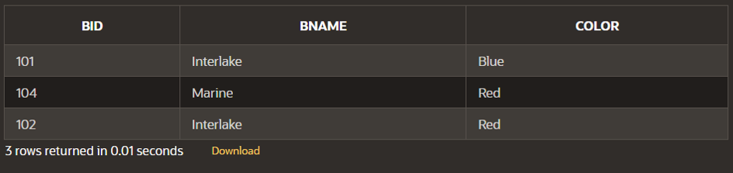

1. **List the details of clients having ‘h’ as a 3rd character in his/her name.**

**Query:**

select * from client where name like ‘__h%’;

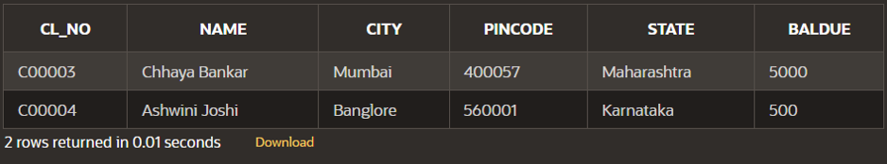

1. **List Client Name, due balance and city whose pin code starts with 4.**

**Query:**

select name, baldue, city from client where pincode like ‘4%’;

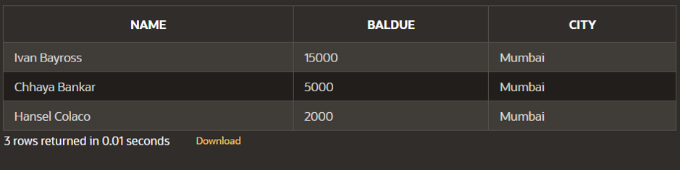

1. **List all customers whose city contains ‘a’ as second character.**

**Query:**

select cname from customers where city like ‘_A%’;

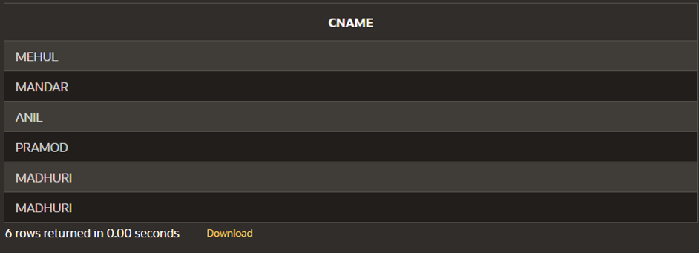

**10. List client names and city whose state has ‘a’ as fourth or fifth character.**

**Query:**

select name, city from client where state like ‘___a%’ OR state like ‘____a%’;

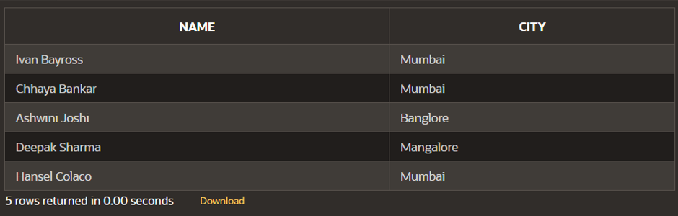

**Practical - No.6**

1. **List total deposit from deposit.**

**Query:**

select sum(amount) from deposit;

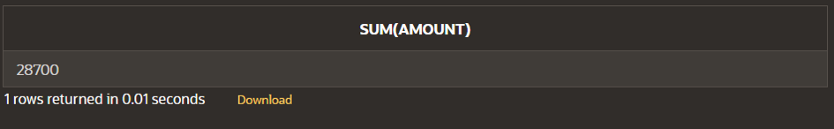

1. **Give maximum loan given to the customer.**

**Query:**

select max(amount) from deposit;

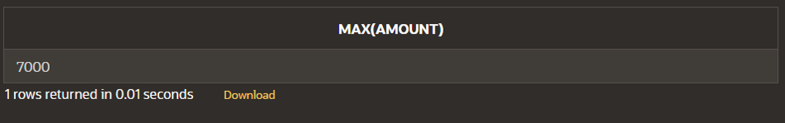

1. **Describe the average age of all the sailors.**

**Query:**

select avg(age) from sailors;

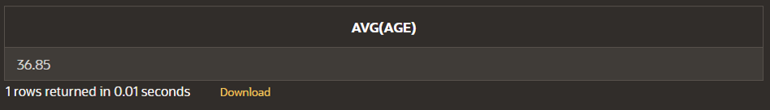

1. **Count total number of customers.**

**Query:**

select count(cname) from customers;

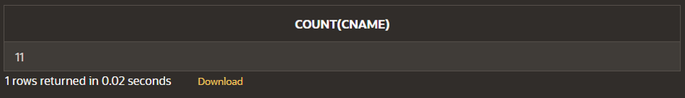

1. **Count total number of customer’s cities.**

**Query:**

select count(city) from customers;

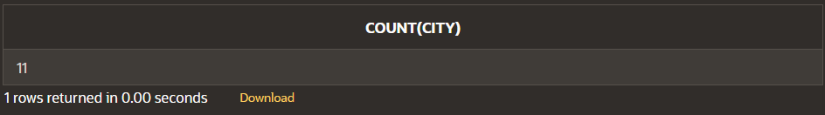

1. **Display total target for the salesman.**

**Query:**

select sum(tgt) from salesman;

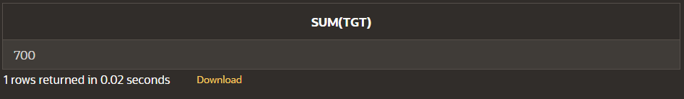

1. **Update the salary of the employee having 10000 to 11500.**

**Query:**

update work set salary = 11500 where salary = 10000;

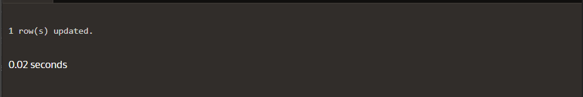

1. **Update the city of client from Bangalore to Bengaluru.**

**Query:**

update client set city = ‘Bengaluru’ where city = ‘Banglore’;

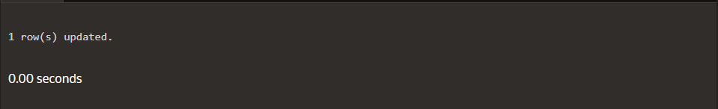

1. **Give the 15% hike in the salary of all the Employees. Rename that column to “New Salary”.**

**Query:**

select salary, salary+(salary*0.15) “New_Salary” from work;

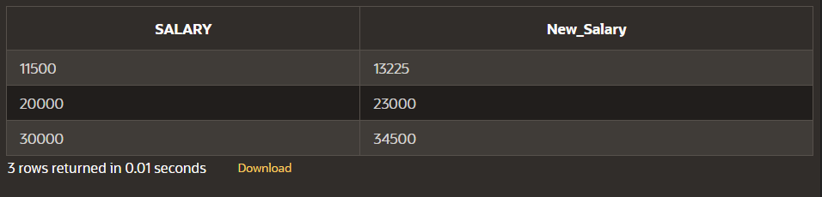

1. **Increase the sell price of all products by 20% and label new column as “New Sell Price”. (Do not update the table)**

**Query:**

select sell_price, sell_price+(sell_price*0.2) “New_Sell_Price” from product;

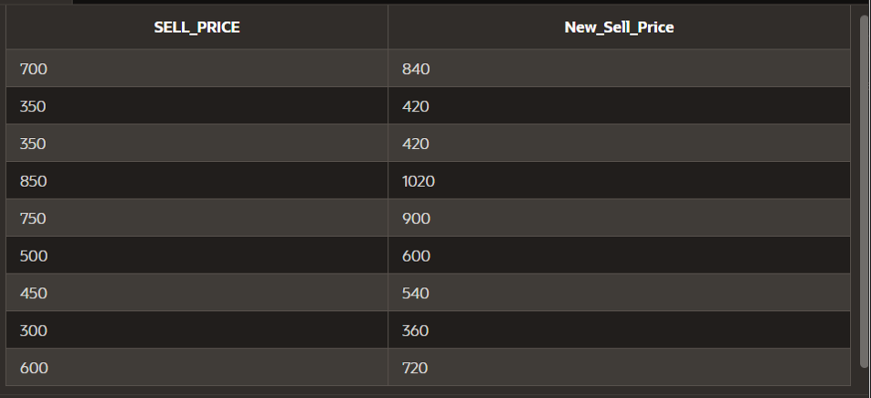

1. **Provide the count of customers staying in “Bombay”.**

**Query:**

select count(cname) from customers where city = ‘BOMBAY’;

